Monte Gualtiere
February 7th, 2021
System Hardening Lab
NTS-103

System Hardening Lab

1. Creating a lower than admin/root account for day-to-day operation:
-In the Control Panel, under User Accounts, I changed my account from an administration to a standard user. This is because it is a safer practice overall.
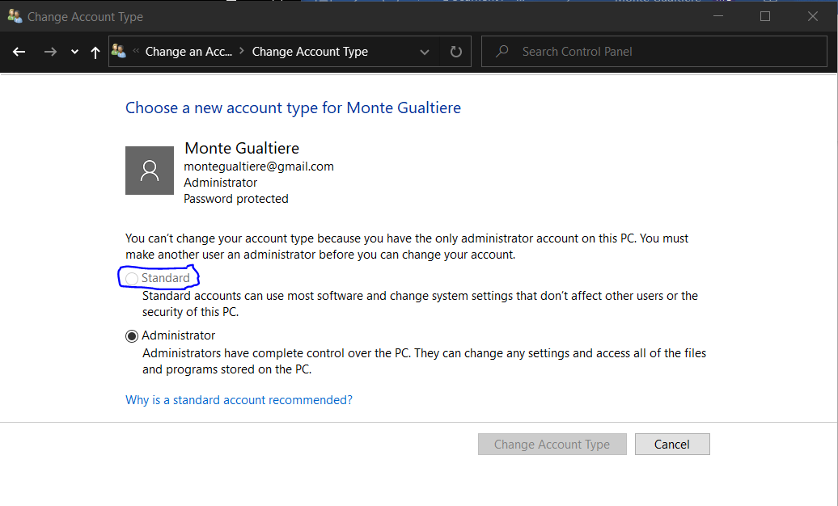

2. Changing the default password:
-In the main setting of the computer, I would recommend changing the default password to something nonpersonal and long. Everyone wants their information to stay protected and safe. This will be the case for me because my password is now stronger and better protected.

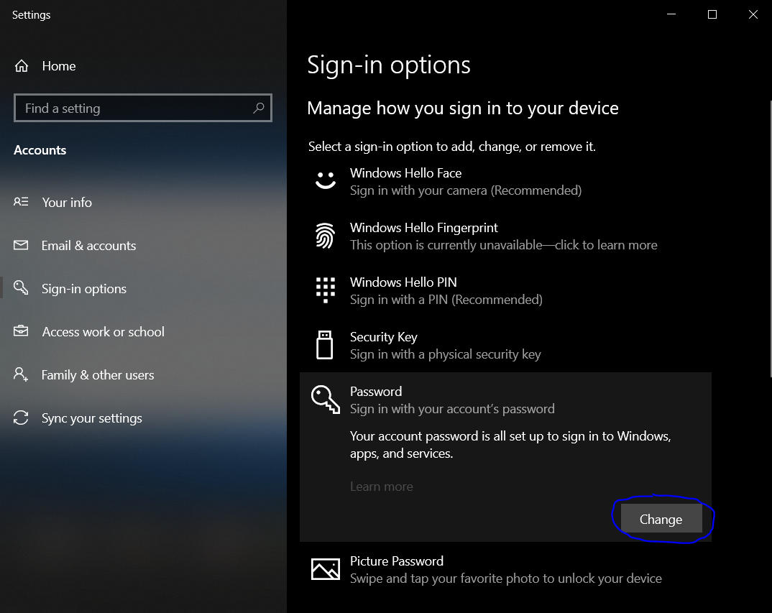

3.Disabling or restricting remote access:
-In the Control Panel, under System and Security, then system protection, I disabled remote access sharing. This will hopefully slow attackers from trying to access my computer remotely.
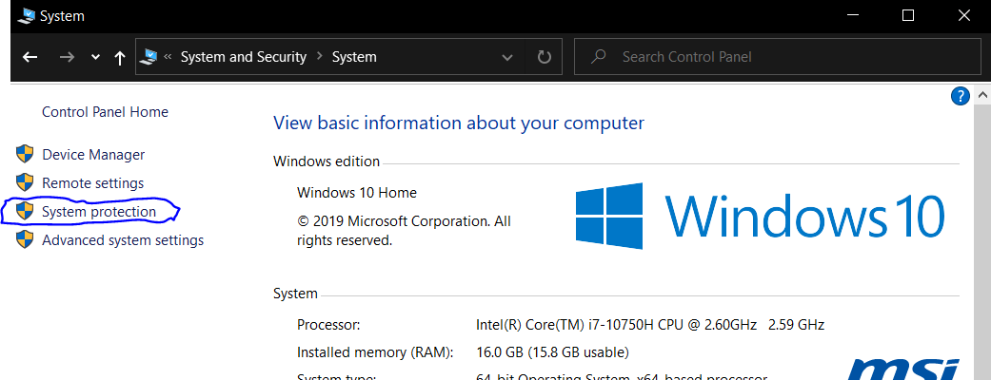

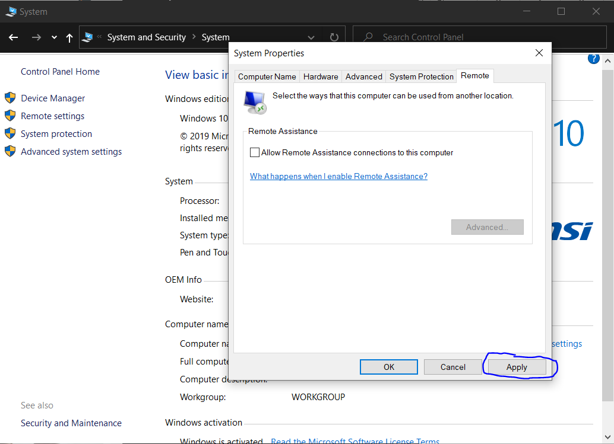
4. Disabling or restricting file sharing:
-I definitely want to disable this feature, this is because I don’t want any companies like google or Microsoft tracking my information. This leads to them creating a profile of me and ultimately having my information sold to other companies.
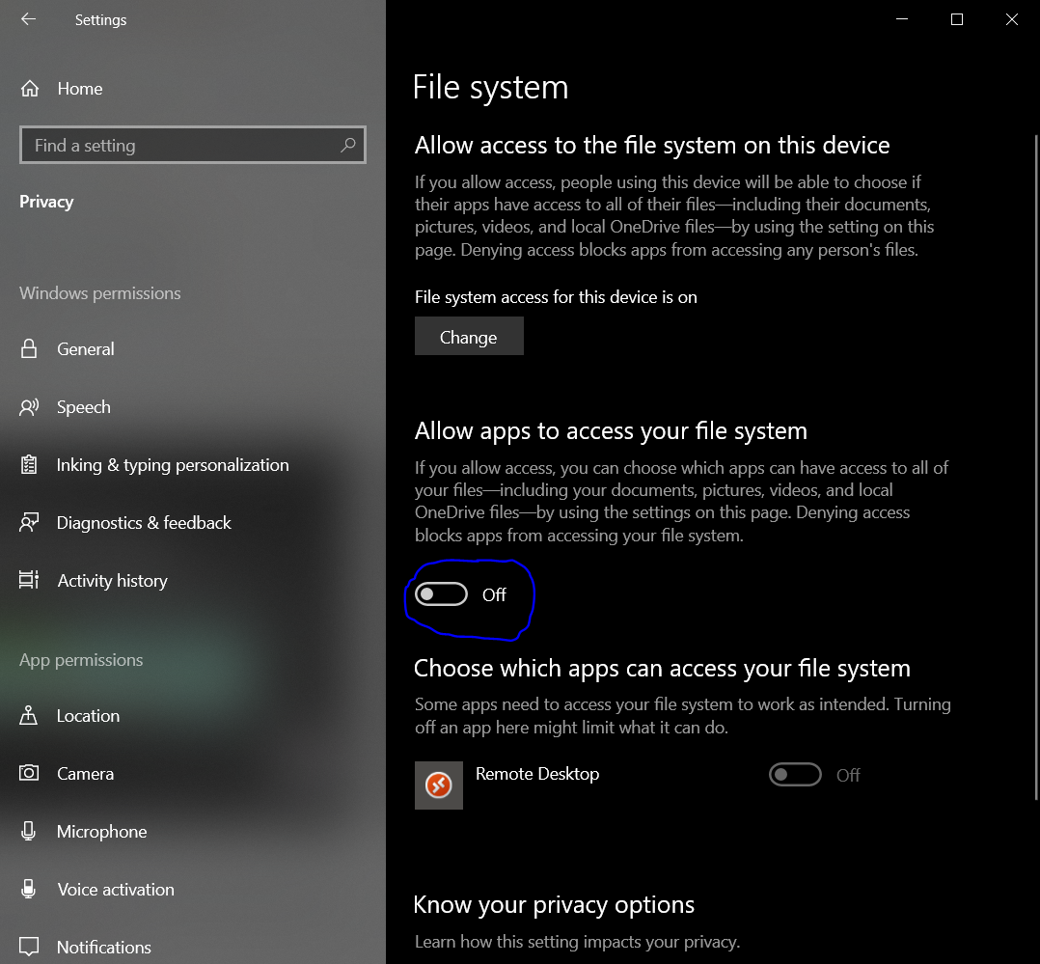

5. Disable Telemetry:
-Disabling this function is very important for multiple people because they want their anonymity. People feel uncomfortable being tracked and don’t want a large company like Microsoft tracking their data. If I had Windows 10 Pro, I would fully disable this function.
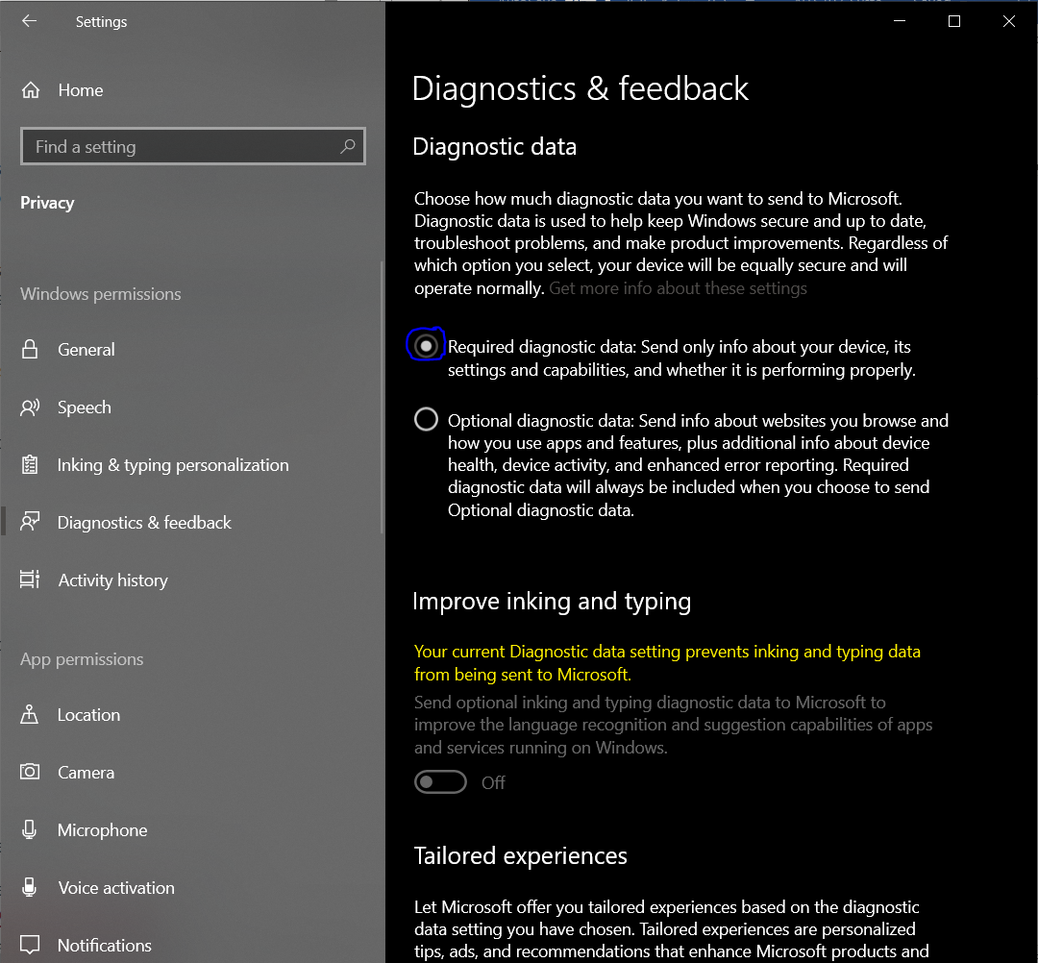

6.Removal of Unnecessary Applications:
-Personally I am not the biggest fan of Cortana, or any application that has access to the microphone to my computer. This is why I recommend disabling all of her features, especially those that listen when the laptop is supposed to be off.
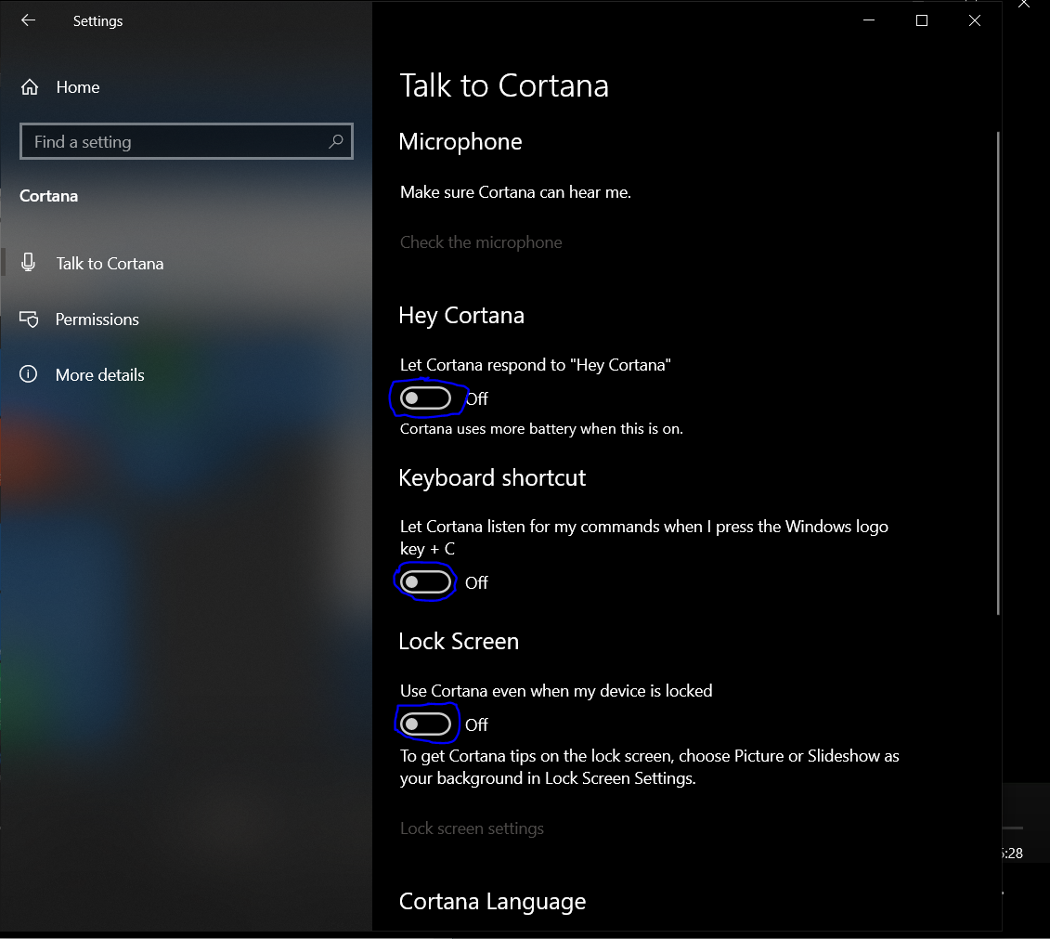

7. Connection Properties:
-In the network settings under change adapter options, I disabled File and Printer Sharing for Microsoft Networks. They say a good engineer only makes one change at a time so they can revert the changes that they have made.

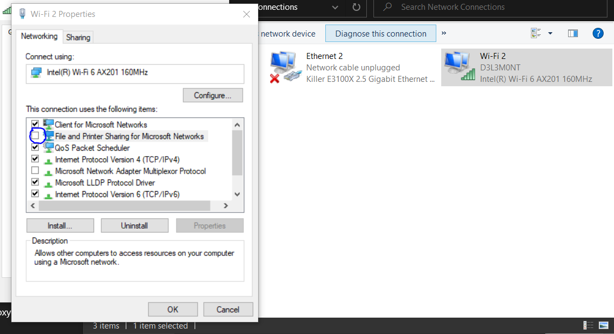

8.Configuring Firewall Options
-According to Gartner, “99 percent of firewall breaches are caused by errors in configuration” (). Breaches, then, are almost always caused by human error, not technology failure. This is why I rely on Norton Security to manage my firewall.
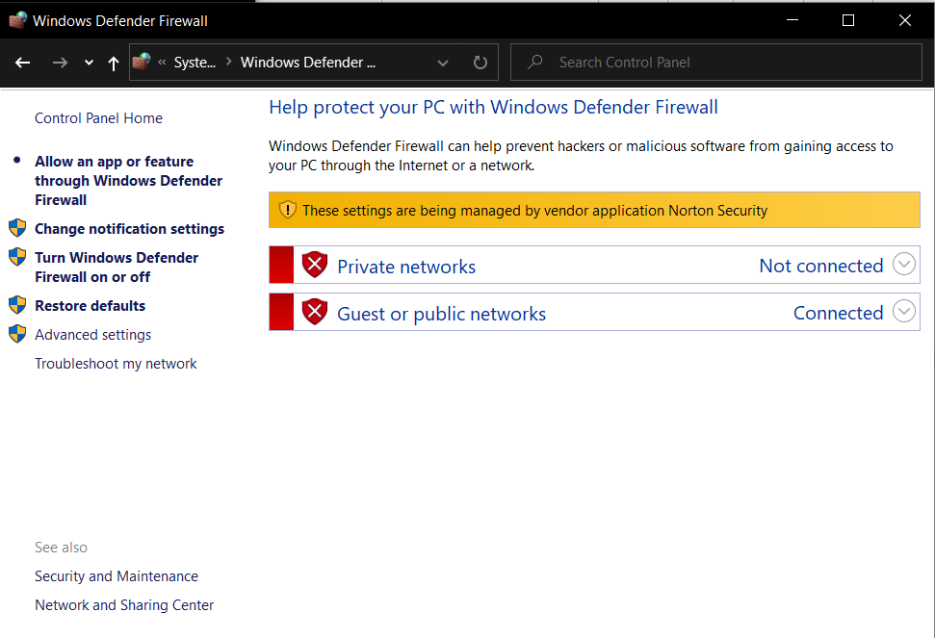
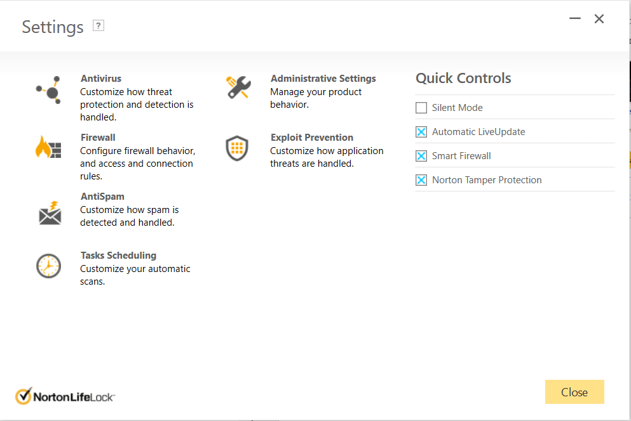
9.Turn on pop-blocker in browser
-The reason for turning on this application is fairly simple. A large amount of attacks come from accidental clicks of random pop ups and adds. The best way to stop this type of threat is to minimize the number of pop ups and adds that can show up.

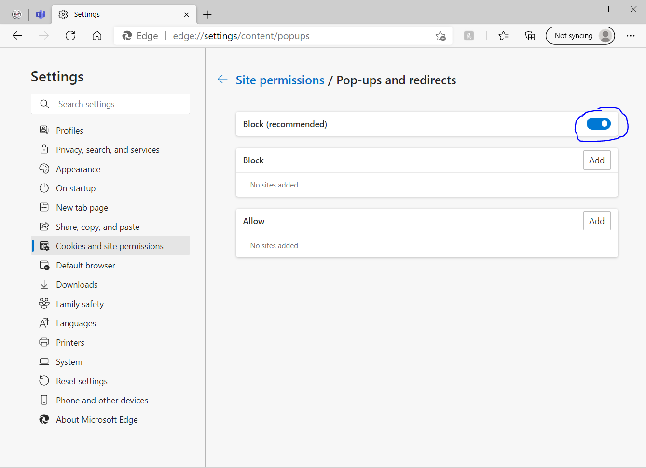

10. Encryption - Enable Microsoft BitLocker
-BitLocker Drive is a secure startup for operation systems, full volume encryption of OS, and removable volumes. This technology promotes users for multiple actions related to their volumes, unlocks volumes when mounted and stores recovery information in the Archive Directory.
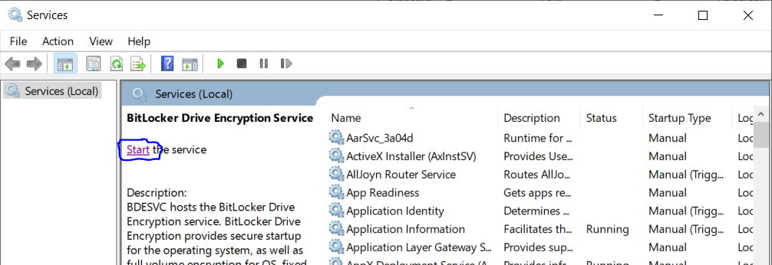
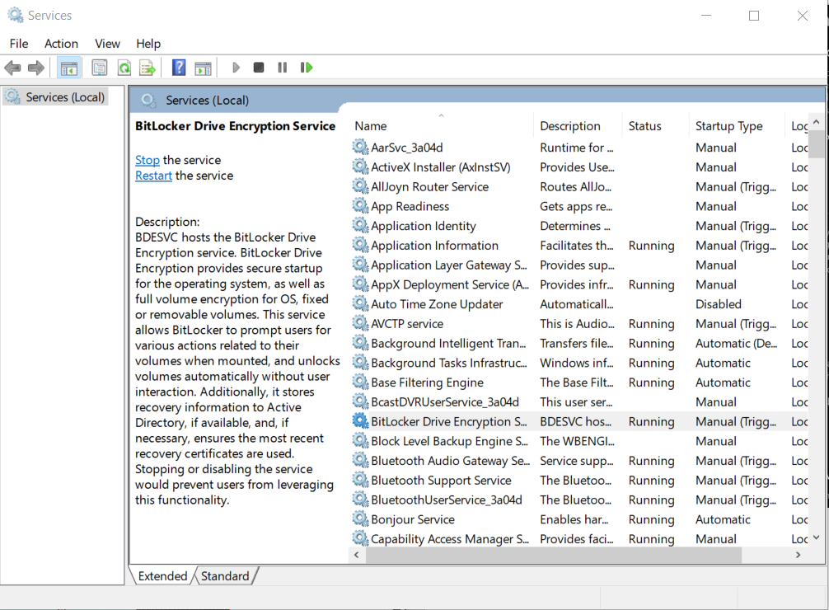
Resources
Harvey, C. (2021, January 28). Fine-tuning firewall rules: 10 best practices. Retrieved February 08, 2021, from https://www.esecurityplanet.com/networks/fine-tuning-firewall-rules-best-practices/

