Monte Gualtiere
12/09/2021
NTS330
Project-06-Final
Try Hack Me
The first two steps of the try hack me assignment where very easy all I had to do was open my VM and connect to the server. I then used nmap to find what services where open on the IP address. After this I was asked to find the hidden directory on the web server. To do this I had to get a little familiar with dirsearch. I looked up a website that could help me install it on my VM and with the command ( sudo python3 dirsearch.py -u 10.10.199.188) I was able to get the answer for number 3.
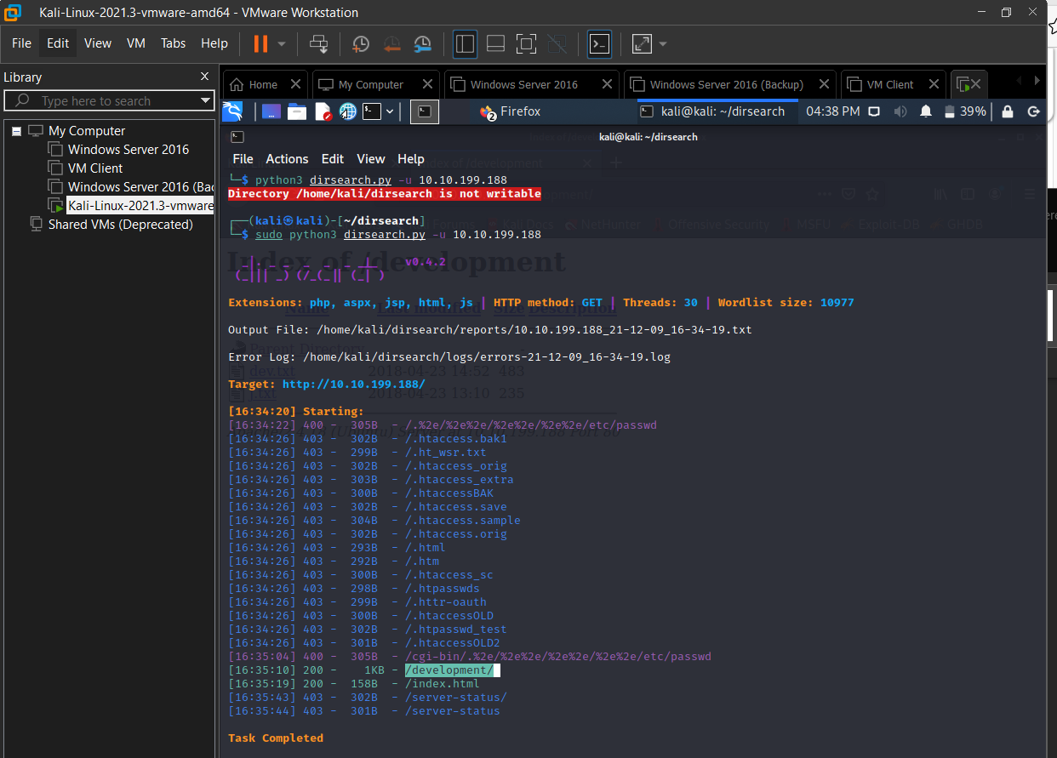
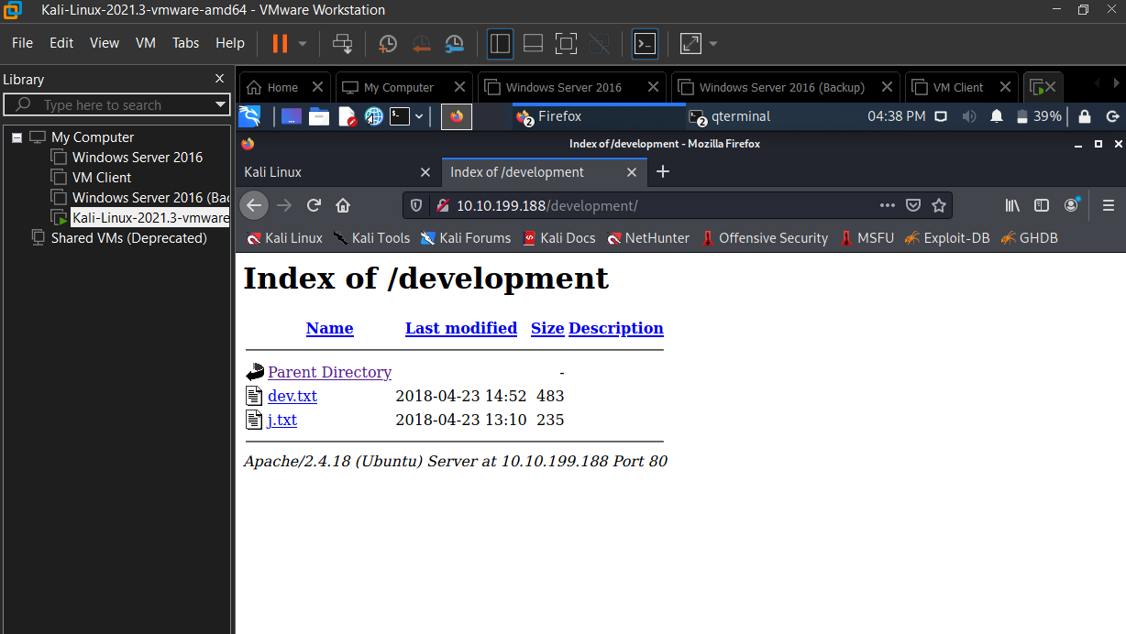
The next question was to find the username. I saw that the user name was only 3 letters and when you would go into the dev text file above the notes end with a persons name of J. I then tried various J names like Joe, Jay, and finally Jan that happened to be the answer.
The next question is to find the Password for this step it took me a little longer then I would have liked but I was able to complete it using hydra and a rockyou file system. The password is armando.

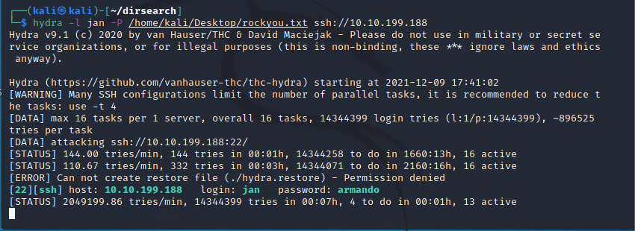
The next question was a simple answer of the things that I have been using so far to get into the system.
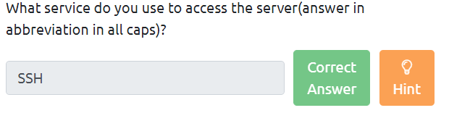
I was able to find the second user Kay that was attached on the directory in the beginning of the assignment. Once I figured out how to SSH into his file I was met with a secondary private key.
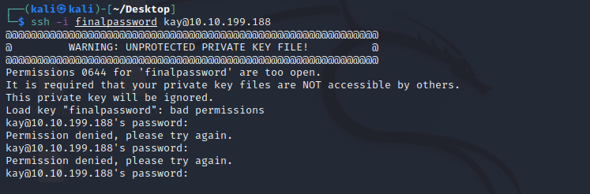
To find the password for this I used a keyhash.txt to help decipher it and got the secondary password beeswax
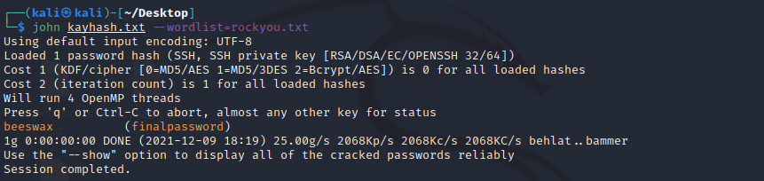
Finally I was able to get the final password.
