Overview:
If you've never looked at all the traffic going across your network card -- you're in for a surprise. Even if you aren't actively surfing the web or playing a game, your network card is busy handling lots of traffic. It isn't uncommon to see hundreds of packets a second on a computer that appears to be idle. Go to https://wireshark.org and install an OS appropriate copy of Wireshark, an industry standard network sniffer.

Guidelines & Deliverables:

1. Download and install Wireshark, and include a post-installation screenshot showing Wireshark.
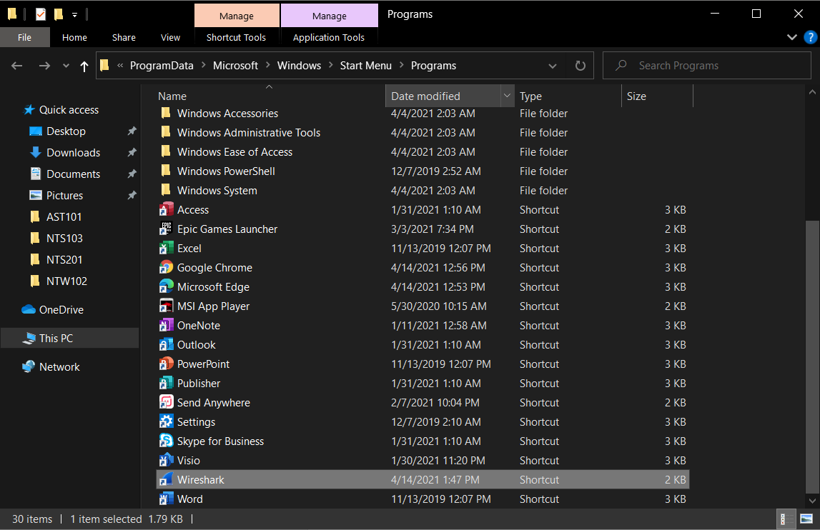
2. Watch the basic Wireshark tutorial here: https://www.youtube.com/watch?v=TkCSr30UojM. If it is unavailable, watch any basic Wireshark tutorial on YouTube. Or (836) Learn Wireshark in 10 minutes - Wireshark Tutorial for Beginners - YouTube

3. Capture traffic on your network for 30 seconds. How many packets total packets were captured? Include a screenshot of the 30s mark of packets.
16,124 packets
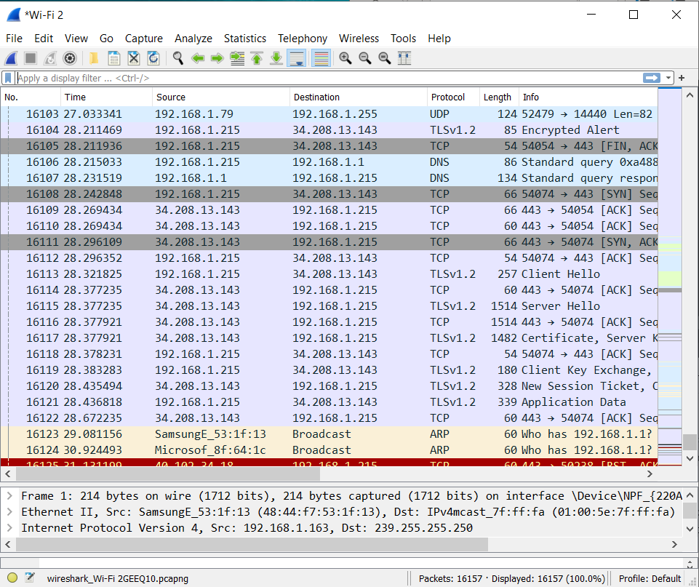

4. Capture traffic for 5 minutes. Stop the capture. Click on the protocol column header, to sort the capture by protocol. How many different protocols did you observe? List them.
HTTP, HTTP/X, DNS, ARP, IGMPv2, SSDP, MDNS, STUN, TCP, TLSv1.2, UDP
11 different protocols

5.-9. Pick 5 protocols that you are not familiar with. Research the function/use of each protocol, and write a few sentences about the function of each protocol for questions 5. through 9.
DNS- Domain Name System
A hierarchical and decentralized naming system for computers, services or other resources connected to the internet. It associates different information with domain names assigned to each of the particular entities. Its main job it to translate more readily memorized domain names to the IP addresses needed for locating and identifying computer services and devices with underlying proticals.
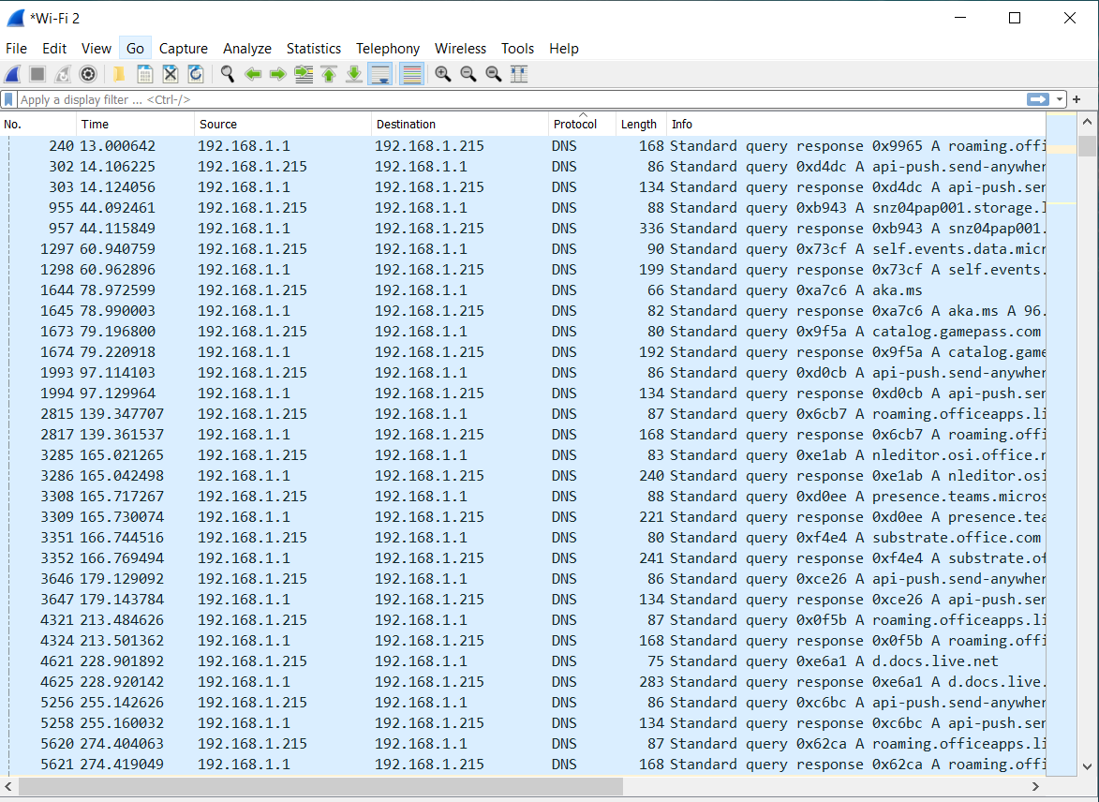

ARP- Address Resolution Protocol
A communication protocol used for discovering the link layer address, like the MAC address, associated with a given internet layer address, typically an IPv4 address, This mapping is a critical function in the internet protocol suite.
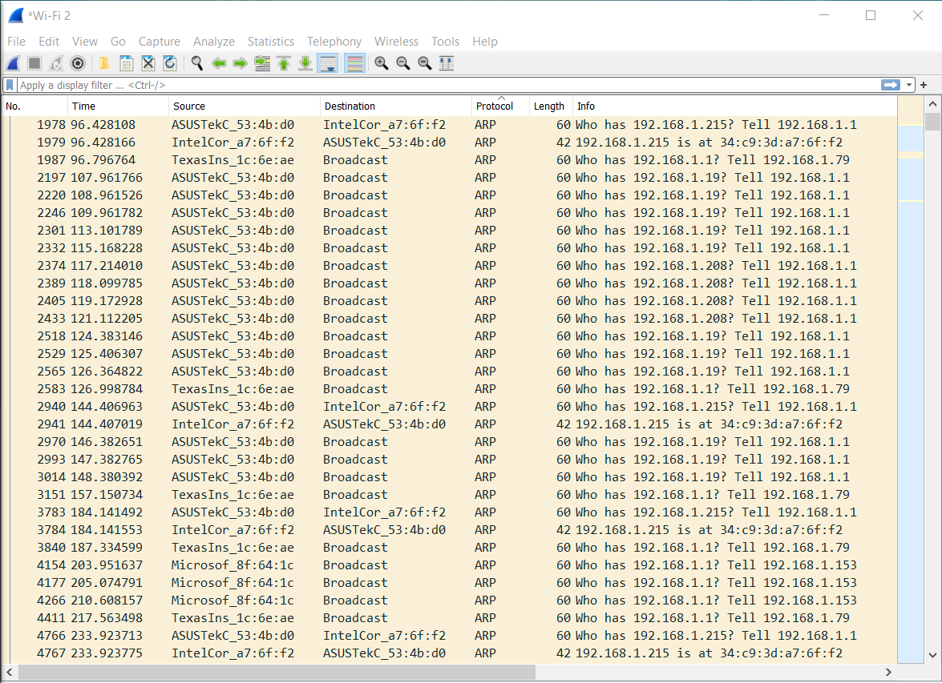

SSDP- Simple Service Discovery Protocol
A network protocol based on the Internet protocol suite for advertisement and discovery of network services and presence information. It accomplishes this without assistance of server-based configuration mechanisms, such as Dynamic Host Configuration Protocol (DHCP) or Domain Name System (DNS), and without special static configuration of a network host.
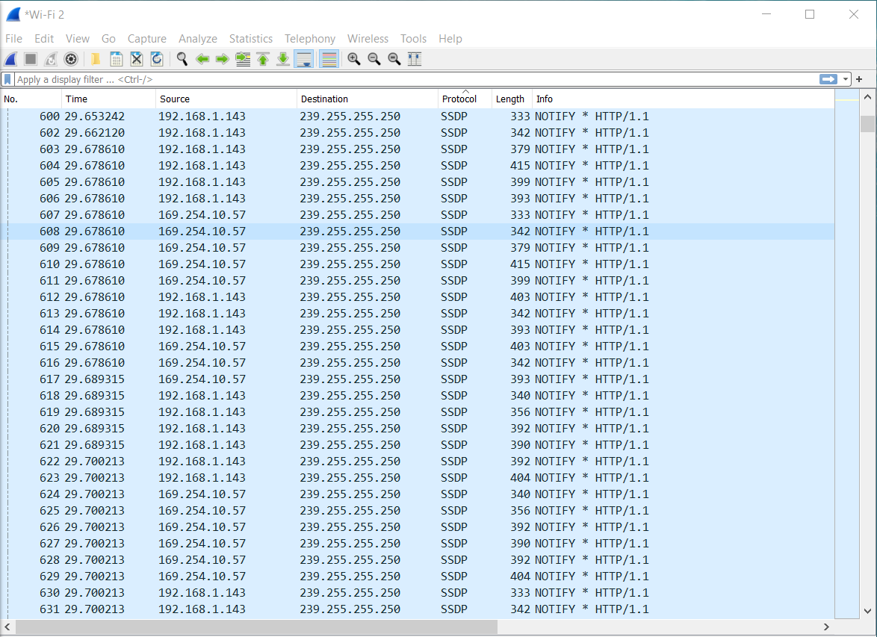

MDNS- Multicast Domain Name system
The multicast DNS (mDNS) protocol resolves hostnames to IP addresses within small networks that do not include a local name server. It is a zero-configuration service, using essentially the same programming interfaces, packet formats and operating semantics as the unicast Domain Name System (DNS). Although Stuart Cheshire designed mDNS as a stand-alone protocol, it can work in concert with standard DNS servers.
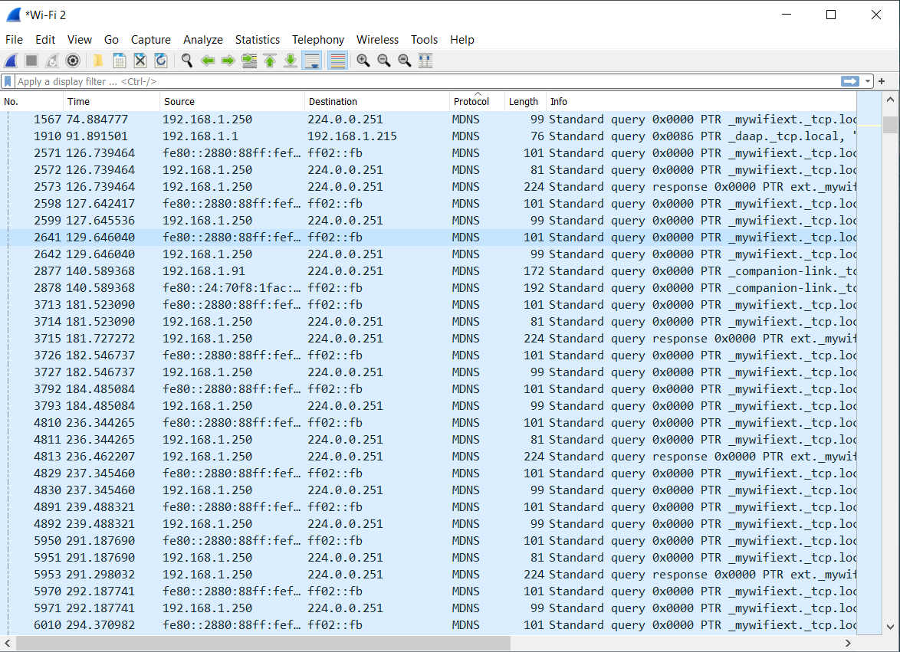

STUN- Session Traversal Utilities for NAT
This is a tool used by other protocols, such as Interactive Connectivity Establishment (ICE), the Session Initiation Protocol (SIP), and WebRTC. It provides a tool for hosts to discover the presence of a network address translator, and to discover the mapped, usually public, Internet Protocol (IP) address and port number that the NAT has allocated for the application's User Datagram Protocol (UDP) flows to remote hosts. The protocol requires assistance from a third-party network server (STUN server) located on the opposing (public) side of the NAT, usually the public Internet.
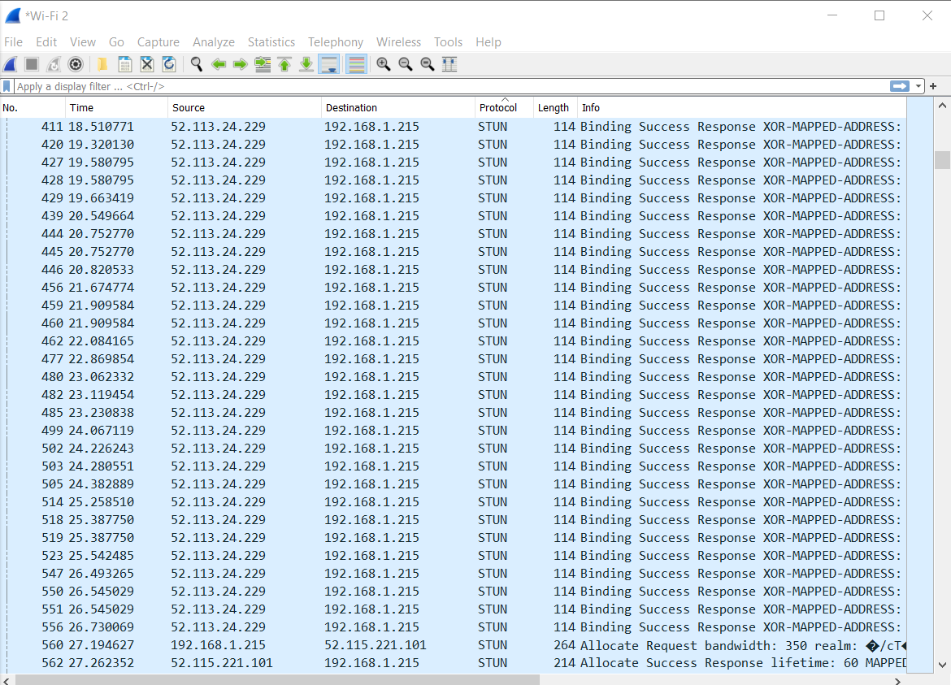

10. Each line in the Wireshark captures includes a source and a destination. How many different destinations did your computer talk to? Sorting by the destination column will make this easier to identify. Include a screenshot of the sorted destinations. It's ok if they don't all show.
In 5 minutes my computer talked to 22 different destinations
