DigiKnight Technologies BCDR Plan
Daniel Mitchell, Devon Caballero-Zarate, Lorenze Salas, Monte Gualtiere
Professor Dan Wilikns

Contents
Cost of Downtime 4
Phase 1 7
Natural Threats 7
Man-Made Threats 8
IT & Technology-based Threats 9
Phase 2 11
Environmental & Infrastructure Threats 11
Prioritize business functions 12
Identify risk mitigation strategies 13
Electricity 13
Facilities 13
Staff 15
Shipping 15
Manufacturing 15
Phase 3 16
Insurance information 16
FEMA possible risk 16
FEMA analysis memo 17
Resources 18
Resources 18
BC/DR Plan 18
Inventory Lists 18
Contact Lists 19
Vendor and Suppliers 19
Computer Developers 19
Blank CD Suppliers (Producing Products) 20
Box (Packaging Software) 20
Paper Supplier (Box Inserts) 21
Service Contractors 21
Computers 21
Office Equipment 22
Phase 4 23
Procedures to activate an alternate worksite 23
Location 23
Cold Site Backup Plan 24
Warm Site Backup Plan 24
Phase 5 26
Hot Site Backup Plan 26
Mobile Site Backup Plan 26
Mirrored Site Backup Plan 27
Procedure to notify the crisis communication command center 28
Location 28
Key Personnel in the Crisis Communication Command Center 29
Phase 6 & 7 30
Backing up data 30
Organizational Chart 31
Phase 8 32
Location of emergency response organizations 32
BC/DR activation steps 33
Log Sequence 33
Determining structural damages, health, safety impacts, and risk template 34
Location & testing of emergency systems 35
Phase 9 36
Evacuation procedures 36
Phase 10 38
Assessment for determining inventory or list of critical resources at damaged site 38
Man-made-based test scenario 38
In the events of a mudslide 38
Phase 11 39
Planned maintenance 39
Advantages & disadvantages of retaining members 39
Recommendation of the BCDR plan up to date 39
Approaches & reviewing the plan 39
References 40

Cost of Downtime
IT: The IT department (excluding databases) consists of employees’ workstations, data flow from servers to the manufacturing equipment, and other miscellaneous equipment such as the PA system. If these systems are offline or unavailable for any reason, we will see the following dollar casualties: $300,000 per hour (The 20, 2021). This is the average cost of IT downtime for a large organization that isn’t 100% dependent on the Internet to function like a cloud-based service.
Manufacturing: Manufacturing consists of the CD stampers used to produce the game discs themselves, as well as high speed printers used to create manuals and in-box ads. “A final machine places all items in a box and the box is sent down a conveyor belt to an employee station that places the finished boxes in a larger box for shipping to stores nationwide” (DigiKnight Technologies, 2020). If for whatever reason the entire manufacturing facility goes offline, we can assume that approximately 365 days divided by the total revenue of last year $200 million (DigiKnight Technologies, 2020), divided again by 24 hours to get an hourly cost: Over $22,800 per hour.
Electricity: Electricity is a necessity in the modern world no matter who you are or what you do. IT, Manufacturing, Sales, Marketing, Research and Development, and almost every department cannot operate at all without electricity. Perhaps the only people that may be able to continue working are those in shipping. That is, the ones currently driving the trucks on the road. Without electricity we can expect a large cost due to unproductivity:
- 57 unproductive workers times an average salary of $30/hr = $1,710 per hour.
- Manufacturing cost: Over $22,800 per hour.
- IT cost: $300,000 per hour
- Sales cost: $300K p/hour
- Total cost: Over $624,510
Staff: The staff that occupied the ground floors all the way up to the higher levels are all important. If there were to be a time when staff are not able to make it into the stores they work at or the manufacturing station they are assigned to the company could suffer a great cost of down time. One example of this was on, “March 2015, a 12-hour Apple store outage cost the company $25 million”
Sales: The Sales Team is an invaluable asset to the business because they are the ones that get the products that the company works so hard to create, out the door. If there were to be a time when the Sales Team were to suffer a cost of downtime this would halt not only the revenue that the company would be making but also the manufacturing side of the business. “Based on industry surveys, the number we typically cite is $5,600 p/minute, which extrapolates to well over $300K p/hour”.
Shipping: The Shipping Team is in the same general area as the Sales Team when it comes to their importance and how much the company relies on them. If the shipping team were to run into a situation where they were not able to get products out to the customers that paid for them, there would be two major things that would hurt the company. First their reputation would be tainted, and it would make customers very unhappy. The second would be the major loss of money the company would take because they are not able to get products out. There could be a loss of, “$5,600 p/minute, to well over $300K p/hour”.
Facilities: All of the facilities were designed in accordance to not only federal, state and local specifications but also with the detailed input from our staff. On top of having state of art tech in our mission critical departments i.e Shipping/Manufacturing, IT, along with R&D, we felt the need to take things a step further. Child care, Gym, Massage, In house chefs, & most importantly a lounge with pool tables, arcade games, lovesacs & OLED Tv’s. At Digiknight we know that our staff are our most important asset
Maintenance: Even with what it is we do here at DigiKnight, our maintenance department is one of our crown jewels. All of our maintenance personnel have either mechanical or electrical engineering & some also have their ASE master certs as well. We’ve known from day one that in order for our staff to do their jobs to the absolute best of their abilities the equipment and the facilities have to be in perfect working order.
Security: This is one facet that we spared absolutely zero expense on. All of our staff is either prior law enforcement or military. On top of human aspect, we have k9 units patrolling the grounds both in and out of the building as well Infrared cameras, retinal scanners, biometric palm scanners, cameras with a 720 degree field of vision. Etc. Our IT security staff is all OSCP, CEH, PNPT, and CISSP certified so if there are those who decide to try and attack us we will not only stop you, but we will find you and prosecute as well.
At the end of the day the bottom line when it comes to finances, profit and loss, long term gain is all important and there’s no denying that. But if your staff’s quality of life and state of mind isn’t one of your utmost priorities then any amount of money you will lose shouldn’t even be a concern because you won’t have a company to run or product to market.

Phase 1

Natural Threats
Threat Source | Threat | Upstream & Downstream | Likelihood of Occurrence | Threat Magantitude
Earthquake | staff unable to work | Upstream: 65%  Downstream: 65% | Unlikely  Possible  Likely  Highly Likely | Negligible  Limited  Critical  Catastrophic
Wildfire | staff unable to work | Upstream: 45%  Downstream: 45% | Unlikely  Possible  Likely  Highly Likely | Negligible  Limited  Critical  Catastrophic
Tsunamis | Product unable to be delivered | Upstream: 10%  Downstream: 10% | Unlikely  Possible  Likely  Highly Likely | Negligible  Limited  Critical  Catastrophic
Tornado | Product unable to be delivered | Upstream: 10%  Downstream: 10% | Unlikely  Possible  Likely  Highly Likely | Negligible  Limited  Critical  Catastrophic
Hurricane | Product unable to be delivered | Upstream: 5%  Downstream: 5% | Unlikely  Possible  Likely  Highly Likely | Negligible  Limited  Critical  Catastrophic
Flash Floods | staff and products unable to deliver the products | Upstream:45%  Downstream: 45% | Unlikely  Possible  Likely  Highly Likely | Negligible  Limited  Critical  Catastrophic
Droughts | affecting public health problems | Upstream: 55%  Downstream: 55% | Unlikely  Possible  Likely  Highly Likely | Negligible  Limited  Critical  Catastrophic
Landslides | debris collapsing to buildings and can lead to injuries/deaths | Upstream: 30%  Downstream: 30% | Unlikely  Possible  Likely  Highly Likely | Negligible  Limited  Critical  Catastrophic

Man-Made Threats

Threat Source | Threat | Upstream & Downstream Impact | Likelihood of Occurrence | Threat Magnitude | Impact on Business Operations
Civil Unrest | Staff unable to work | Upstream: 55%  Downstream: 55% | Unlikely  Possible  Likely  Highly Likely | Negligible  Limited  Critical  Catastrophic | Low  Medium  High
Traffic Stoppage | Staff unable to work | Upstream: 85%  Downstream: 85% | Unlikely  Possible  Likely  Highly Likely | Negligible  Limited  Critical  Catastrophic | Low  Medium  High
Sickness | Staff unable to work | Upstream: 5%  Downstream: 35% | Unlikely  Possible  Likely  Highly Likely | Negligible  Limited  Critical  Catastrophic | Low  Medium  High
Active Shooter | Staff unable to work | Upstream: 95%  Downstream: 95% | Unlikely  Possible  Likely  Highly Likely | Negligible  Limited  Critical  Catastrophic | Low  Medium  High
Theft | Product unable to be delivered | Upstream: 0%  Downstream: 20% | Unlikely  Possible  Likely  Highly Likely | Negligible  Limited  Critical  Catastrophic | Low  Medium  High
Arson | Staff unable to work | Upstream: 90%  Downstream: 90% | Unlikely  Possible  Likely  Highly Likely | Negligible  Limited  Critical  Catastrophic | Low  Medium  High
Trucker’s Strike | Product unable to be delivered | Upstream: 90%  Downstream: 90% | Unlikely  Possible  Likely  Highly Likely | Negligible  Limited  Critical  Catastrophic | Low  Medium  High

IT & Technology-based Threats

Threat Source | Upstream & Downstream | Likelihood of Occurrence | Threat Magantitude | Impact on Business Operations
Botnets | Upstream: 30%  Downstream: 5% | Unlikely  Possible  Likely  Highly Likely | Negligible  Limited  Critical  Catastrophic | Low  Medium  High
Smurf Attack | Upstream: 40%  Downstream: 20% | Unlikely  Possible  Likely  Highly Likely | Negligible  Limited  Critical  Catastrophic | Low  Medium  High
IP Spoofing | Upstream: 60%  Downstream: 60% | Unlikely  Possible  Likely  Highly Likely | Negligible  Limited  Critical  Catastrophic | Low  Medium  High
Phishing | Upstream: 5%  Downstream: 10% | Unlikely  Possible  Likely  Highly Likely | Negligible  Limited  Critical  Catastrophic | Low  Medium  High
Trojan Virus | Upstream: 25%  Downstream: 25% | Unlikely  Possible  Likely  Highly Likely | Negligible  Limited  Critical  Catastrophic | Low  Medium  High
Ransomware | Upstream: 30%  Downstream: 30% | Unlikely  Possible  Likely  Highly Likely | Negligible  Limited  Critical  Catastrophic | Low  Medium  High
Rogue security software | Upstream: 40%  Downstream: 40% | Unlikely  Possible  Likely  Highly Likely | Negligible  Limited  Critical  Catastrophic | Low  Medium  High

Phase 2

Environmental & Infrastructure Threats
Threat Source | Threats | Upstream & Downstream | Likelihood of Occurrence | Threat Magantitude | Impact on Business Operations
Earthquake  (Environmental) | Staff unable to work and damage buildings | Upstream: 65%  Downstream: 65% | Unlikely  Possible  Likely  Highly Likely | Negligible  Limited  Critical  Catastrophic | Low  Medium  High
Wildfire  (Environmental) | Staff unable to work and set buildings on fire | Upstream: 45%  Downstream: 45% | Unlikely  Possible  Likely  Highly Likely | Negligible  Limited  Critical  Catastrophic | Low  Medium  High
Flash Floods  (Environmental) | Staff and products unable to deliver the products | Upstream:45%  Downstream: 45% | Unlikely  Possible  Likely  Highly Likely | Negligible  Limited  Critical  Catastrophic | Low  Medium  High
Landslides  (Environmental) | Debris collapsing to buildings and can lead to injuries/deaths | Upstream: 30%  Downstream: 30% | Unlikely  Possible  Likely  Highly Likely | Negligible  Limited  Critical  Catastrophic | Low  Medium  High
Terroism  (Infrastructure) | Destruct buildings and harm staff members | Upstream: 45%  Downstream: 85% | Unlikely  Possible  Likely  Highly Likely | Negligible  Limited  Critical  Catastrophic | Low  Medium  High
Rioting  (Infrastructure) | Destroy minor infrastructure and property | Upstream: 10%  Downstream: 5% | Unlikely  Possible  Likely  Highly Likely | Negligible  Limited  Critical  Catastrophic | Low  Medium  High
Infrastructure material failure  (Infrastructure) | Building collapsing due to an issue within the facility | Upstream: 50%  Downstream: 70% | Unlikely  Possible  Likely  Highly Likely | Negligible  Limited  Critical  Catastrophic | Low  Medium  High

Prioritize business functions
Business Function | Direct Indirect Tertiary | Recovery Time, MTD | Financial Impact | Business Criticality | Operacional Impact
1. Electricity | Direct Indirect Tertiary | 1 - 3 Hours | Over $324,510  p/hour | Negligible  Limited  Critical  Catastrophic | Low  Medium  High
2. Facilities | Direct Indirect Tertiary | 1 Hour - 1 Day | $50,000  p/hour  3,000,000  p/day | Negligible  Limited  Critical  Catastrophic | Low  Medium  High
3. Staff | Direct Indirect Tertiary | 1 - 7 Days | $3,000  p/day  (for 50 staff) | Negligible  Limited  Critical  Catastrophic | Low  Medium  High
4. Shipping | Direct Indirect Tertiary | 1 - 2 Days | $300,000 p/hour | Negligible  Limited  Critical  Catastrophic | Low  Medium  High
5. IT | Direct Indirect Tertiary | 1 - 3 Hours | $300,000 per hour | Negligible  Limited  Critical  Catastrophic | Low  Medium  High
6. Network | Direct Indirect Tertiary | 10 Min - 1 Hour | $7,900 p/Min | Negligible  Limited  Critical  Catastrophic | Low  Medium  High
7. Manufacturing | Direct Indirect Tertiary | 1 - 7 Days | Over $22,800 p/hour | Negligible  Limited  Critical  Catastrophic | Low  Medium  High

Identify risk mitigation strategies

Electricity
Recovery requirements: Power must be restored to at least manufacturing and shipping.
Recovery options:
- Backup generators. A minimum of two 24kW generators will be needed for the manufacturing process and the loading of trucks. A Generac Guardian generator will run approximately $5,427 and requires propane as fuel. Some generators including this model provide grid monitoring so that if the grid stops supplying power, the generator will immediately kick on, thus allowing operations to continue without hindrance (Apelectric, n.d.). A small supply of propane should also be kept on hand to fuel the generators. Propane prices fluctuate, but recently have been around $2.80 per gallon. A small price to pay for power.
- Call the electricity company and have an electrician resolve the issue. This would not cost anything as the electricity company will be required to resolve the issue regardless, but calling them may help expedite the process.
Recommend recovery options: (1) Backup generators. This will put the control of how we do business firmly in our hands. We will not need to rely on when the electric company may repair the grid or not.

Facilities
Recovery requirements: A location suitable to receive supplies, stamp CDs, print inserts for CDs, and a location to load trucks.
Recovery options:
- Purchase a backup location. A secondary facility will need to be prepared to be used, preferably in a different region than our original facility. This way localized disasters such as earthquakes or fires should not affect our backup site. This location only needs space enough for manufacturing and a place to load/unload trucks. Our current manufacturing facility is 8,000 square feet, so a location with roughly that size or slightly less should do excellently. There are companies that sell entire metal buildings that can be popped up wherever they are needed. A certain manufacturer will construct an 8,000 square foot building for $90,899 (QE Buildings, n.d.). We will need to contact a manufacturer to get an exact estimate of time to completion, but this building will provide all the basic necessities: Electricity, space, and a place to load and unload trucks. We will still need to set up our equipment inside once the building is completed. 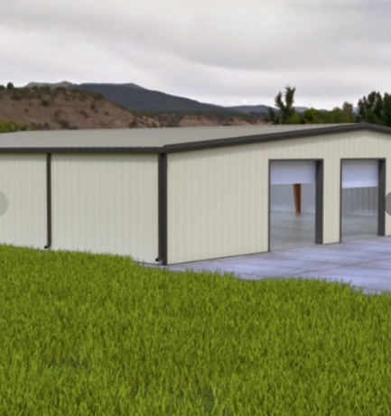
- Rent a backup location. When the primary facility becomes unavailable, we will need to rent out sufficient space and fill it with our equipment. Warehouse spaces in the bay area of California are around $15 per square foot per year. Assuming we get a warehouse with around 8,000 square feet, that will run us about $120,000 per year or approximately $10,000 per month (Loopnet, n.d.).
Recommend recovery options: If we can expect a very long time before our primary facility is up and running, then option (1) of purchasing a location will benefit us in the long run, however, if we do not expect to be down from our primary facility for more than a few months, then option (2) will be preferable as renting a location will cost less and take less time to set up than purchasing and constructing a location.

Staff
All staff from every department have designated duties that are explained in detail from day one, and if they are carried out to the letter success is all but guaranteed. Also all staff understand that we are more than just coworkers but family as well so if one of us is falling short or hurting there will always be someone to help pick them up and help them get that job done.

Shipping
All local in town orders will be delivered within an 1 hr after payment clears. All other shipments either CONUS or International will be shipped within a maximum of 4 hrs of payment clearing.

Manufacturing
All manufacturing is done to exact customer specifications and every piece is used which serves a dual purpose. First, to keep any and all waste to a bare minimum as well as ensuring max ROI on materials. The Manufacturing and Shipping departments run with 4 teams per shift that switch out halfway throughout the day making sure that everyone remains fresh, alert and safe.

Phase 3

Insurance information
- Insurance Provider: Progressive Gecko Farmers
- Insurance Coverage:
  - Property - $25,000 per month for $1 million coverage on property damage and theft or destruction of property.
  - Liability - $10,000 per month for $500,000 coverage of damage of property and bodily damage (Worker’s comp).
  - Cyber - $100,000 per month for $5 million coverage on replacement of IT equipment.
When an event occurs that falls into one of the above categories, the appropriate manager will perform the following:
- Assess damage to employees and/or property or equipment.
- Record every detail about the event from eyewitnesses and/or security cameras. This includes taking photos of relevant areas.
- Contact the insurance company as soon as possible at (123) 456-7890.
In the event of a data breach we will also need to consult legal advisors to determine what next steps may be.

FEMA possible risk
As reported by FEMA there are 4 major hazards to a business, those being, Earthquakes, Dam Safety, Windstorms, and Hurricanes. When it comes to managing earthquakes “The National Earthquake Hazards Reduction Program (NEHRP) leads the federal government’s efforts to reduce the fatalities, injuries and property losses caused by earthquakes” (Security, 2022). Dam Safety is a vital role that is needed to play a vital role in the nation’s overall infrastructure. “The National Dam Safety Program is a partnership of states, federal agencies and other stakeholders to encourage and promote the establishment and maintenance of effective federal and state dam safety programs to reduce the risk to human life, property, and the environment from dam related hazards”(Security, 2022). On the thought of windstorms, Congress established the National Windstorm Impact Reduction Program (NWIRP). This organization plays a crucial role in “ The development of risk assessment tools and effective mitigation techniques, Windstorm related data collection and analysis, Public outreach and information dissemination, and Promotion of the adoption of windstorm preparedness and mitigation measures” (Security, 2022). Finally, on the topic of Hurricanes, “The National Hurricane Program (NHP) provides data, resources and technical assistance for hurricane evacuation planning and response for state, local, tribal, territorial and federal government partners” (Security, 2022).

FEMA analysis memo
FEMA next to our own disaster and emergency recovery plans will be absolutely critical in conjunction with our insurance in order for us to bounce back in case of such. After meeting with the leaders of FEMA we have been assured that not only will medical and payroll care be given to the staff but also a clean up crew will be dispatched to help rebuild and get us back running again.

Resources

Resources
Departments | Computer Equipment | Communication Links | Communication Equipment | Office Equipment | Office Suppliers
Administration | 10 | 1 | 6 | 20 | 3
Sales, R&D Shipping, Advertising, Purchasing | 27 | 2 | 30 | 58 | 10
IT Workstations | 5 | 5 | 5 | 10 | 0
IT Servers | 10 | 2 | 0 | 20 | 2
Other | 0 | 0 | 16 | 16 | 0
TOTAL | 52 | 10 | 57 | 124 | 15

BC/DR Plan
Event Threat | Threat Descriptions | Threat Magantitude | Financial Losses | Recovering Time

Inventory Lists
Inventory ID | Name | Description | Unit Price | Quantity in Stock | Discontinued?

Contact Lists
Title/Department | Manager | Phone #
Administration | Mark Saunders | 415-555-8643
Sales | Diane Ford | 415-555-6312
Manufacturing | Linda Kraemer | 415-555-6161
Research & Development | Carlton Bowden | 415-555-3223
Maintenance | Michael Winters | 415-555-3970
Advertising | Michael Churchill | 415-555-3131
Shipping | Kenneth Gilliam | 415-555-6431
Purchasing | Katherine Cavenaugh | 415-555-3298
Security | Brett Kelcey | 415-555-3852
IT | Alicia McKellips | 415-555-8352

Vendor and Suppliers

Computer Developers
- Dell
  - Address: One Dell Way, Round Rock, Texas 78682
  - Phone #: (800) WWW-DELL or (512) 723-4208
- HP
  - Address: 3000 Hanover Street Palo Alto, CA 94304
  - Phone #: (800) 282-6672
- Boldata Bold Data Technology, Inc.
  - Address: 47540 Seabridge Dr, Fremont, CA 94538
  - Phone #: (800) 923-BOLD or (510) 490-8296

Blank CD Suppliers (Producing Products)
- The Tech Geek (Primary Supplier)
  - Address: 48965 Warm Springs Blvd, Fremont, CA 94539
  - Phone #: (800) 456-0825
- Disc Makers (Secondary Supplier (In emergency))
  - Address: 7905 N. Route 130, Pennsauken, NJ 08110-1402
  - Phone #: (800) 468-9353 or (856) 663-9030
- Dub-It Media Services (Secondary Supplier (In emergency))
  - Address: 1110 North Tamarind Avenue, Hollywood, California 90038
  - Phone #: (323) 993-9570
- ISSI Business Solutions (Secondary Supplier (In emergency))
  - Address:22122 20th Ave SE #152, Bothell, WA 98021
  - Phone #: (800)660-3586 or (425) 483-4801

Box (Packaging Software)
- Customized Packaging Solutions Inc. (Primary Supplier)
  - Address: 8333 24th Avenue P.O. Box 278060 Sacramento, CA 95826
  - Phone #: Unknown
- The Packaging House, Inc. Secondary Supplier (In emergency)
  - Address: 6330 North Pulaski Road Chicago, Illinois 60646
  - Phone #: (800) 966-1808

Paper Supplier (Box Inserts)
- JC Paper
  - Address: 47422 Kato Rd Fremont, CA 94538
  - Phone #: (510) 413-4700

Service Contractors

Computers
- Dell
  - Contract #: 42368131588-DGK
  - Contract Expiration: Every year on December 29th
    - NOTE: The contract expiration can be renewed every year
  - Serial #: DGK12389-# (labeled 1-25)
  - Service #: (888) 555-5897
- HP
  - Contract #: DGK-13548253
  - Contract Expiration: Every year on February 22nd
    - NOTE: The contract expiration can be renewed every year
  - Serial #: DGK55879-# (labeled 1-22)
  - Service #: (888) 555-5237
- Boldata
  - Contract #: DGK1161
  - Contract Expiration: Every three years on March 9th
  - Serial #: DGK-# (labeled 1-3)
  - Service #: (888) 555-1497
- We Sell Software Inc.
  - Contract #: DK823892
  - Service #: 1-888-9876

Office Equipment
- Copy / Fax machines
  - Contract #: OEIDKG-125
  - Contract Expiration: Every year on November 7th
  - Serial #: DGK191
  - Service #: (888) 555-1576
- Production Machines
  - Contract #: WFDK4898
  - Contract Expiration: N/A
  - Serial #: N/A
  - Service #: (888) 555-0567
    - NOTE: The machines were custom built, contact We Fix’Em for more details

Phase 4

Procedures to activate an alternate worksite
If the main facility gets one of the following:
- environmental threats,
- technology-based threats,
- or artificial threats.
An alternative worksite would be beneficial in a Business Continuity Plan. People in the facility perform better and get work done. Additionally, companies expected DigiKnight Technologies Inc. to deliver their product at a high standard.

Location
2001 Front St, Sacramento, CA 95818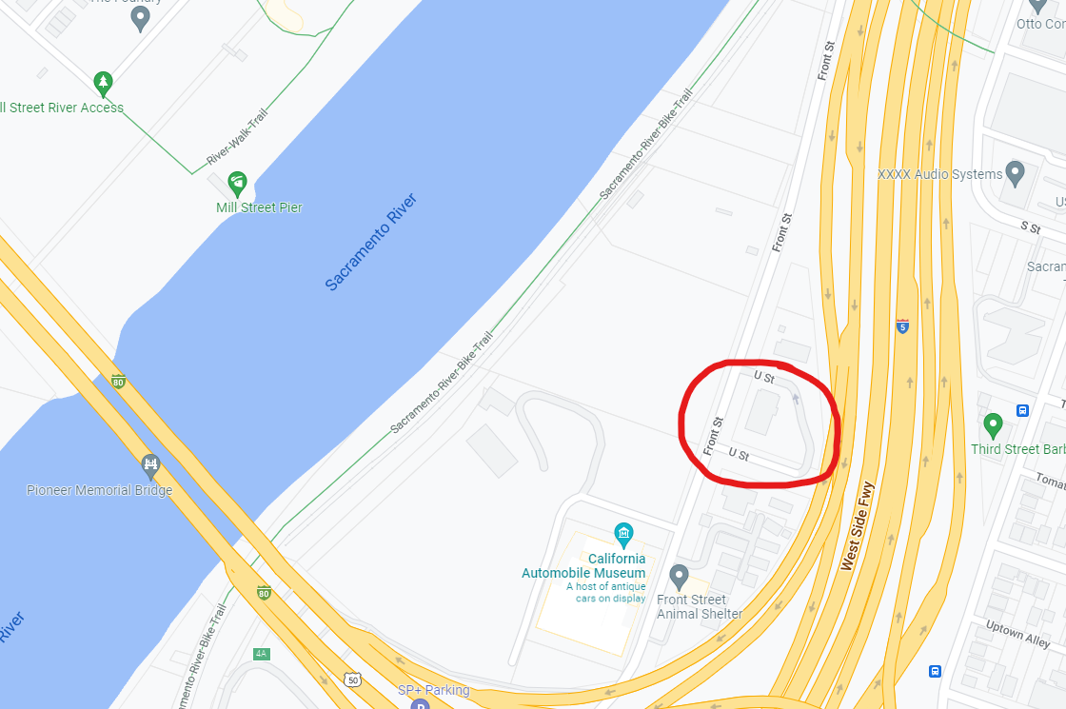
Taken from Google Maps

Cold Site Backup Plan
As our main facility is in San Francisco, CA we will need a cold site somewhere outside the purview of the Bay Area, but close enough that our employees will be able to reach the site or be relocated to the site for the duration of the disaster. A cold site is a location where the infrastructure already exists, but it is not yet equipped with the tech needed to operate our business (Crocetti, 2018). The area near Sacramento, California is far enough away from the bay area so that disasters localized to San Francisco such as tsunamis or earthquakes should not affect the use of our cold site location in that area. Many industrial spaces are available for rent in that area and we will only need to pay around $10 per square foot per year. For 8,000 sq ft, this would cost around $80,000 per year or $6,700 per month (Loopnet, n.d.).
Should we need to use this cold site, we will need to move equipment from our primary facility if possible, or simply buy new equipment to fill our cold site with. We will need CD Stampers, Laser printers, and machinery to pack and move boxes in and out of trucks. So it will take a few days up to a couple of weeks to get the cold site operational. This, however, will most likely be the cheapest option in the short term.

Warm Site Backup Plan
When it comes to the Warm Site, it is considered the middle ground between the cold site and the hot site. This facility will be the backup facility that has the network connectivity and the necessary hardware equipment already pre-installed. The site will not be able to perform on the same level as the production center because they are not equipped in the same way. Therefore, a warm site has less operational capacity than the primary site.
The biggest benefit that the Cold Site will bring to Digiknight will be that it is another space for disaster recovery and is very cheap compared to the Cold Site. On the other hand in comparison to the Warm Site, Cold Sites usually contain even fewer facilities than a Warm Site would. “Cold Site will take more time than a Warm Site or Hot Site to switch operation but it is the cheapest option” (Reed, 2020). “The Cold Site may contain tables, chairs, bathrooms, and basic technical facilities but will require days or even weeks to set up properly and start operation from the Cold Site” (Reed, 2020).

Phase 5

Hot Site Backup Plan
A hot site, to be a hot site, needs to be almost completely prepared for when it is called into operation. Very little work should need to be done in order to get our operations back up and running again. When the primary site goes down we will need to immediately coordinate with the crisis command center and the hot site to plan what final preparations need to be made. It will be expensive to maintain, but well worth it when we are able to continue operations almost unhindered (Reed, 2020). This site will be essentially a copy of the critical operations at DigiKnight. The production facility with its CD stampers, laser printers, and equipment for boxing and unboxing such as forklifts. A database will also be stored at the hot site, but it does not need a live copy of the data. It must be backed up on a daily basis.
This will allow our employees to simply travel to the hot site, turn on the equipment and return to business. It will be expensive, but it will save us the cost of downtime associated with activating a colder backup site.

Mobile Site Backup Plan
When it comes to a mobile backup location a great choice would be a cloud backup. A Cloud Backup has been around for a while and consists of sending a copy of the company's data to an offsite vendor to safely store valuable information at the cost of a small fee. “With cloud backup solutions, sensitive data is stored at a special facility specifically designed for storing data with state-of-the-art security systems” (Support, 2021).
There are three major pros to using Cloud Storage. First, data is accessible from anywhere at any time. “Having your valuable data in the cloud makes it available anytime as long as you have an Internet connection, there is also the added benefit of being able to grant different levels of access to your employees” (Support, 2021). The second pro is that Cloud Storage is extremely efficient and reliable. “The best cloud backup solutions providers use state-of-the-art facilities, they utilize the latest innovations in hardware and software” (Support, 2021). The last pro is that Cloud Security is very secure. Some vendors are housed on multiple power grids with 24/7 on-site armed security. If the company were to be looking for a cloud backup provider, ask about encryption. “A few specialized data centers use military-grade data encryption for enhanced security purposes” (Support, 2021).
As with any form of protection, there are always weak spots, but the pros far outnumber the cons. The primary downsides to Cloud storage are the company can’t access its data if they don’t have Internet access if there are bandwidth issues and the amount of time it might take to fully recover lost storage.

Mirrored Site Backup Plan
Our plan for a mirrored backup is truly not a very complicated one. Our solution for an offsite backup is to implement a hadoop cluster Since our mirror site will only be active during the preset times that we have our onsite backups being run we were able to keep our cost relatively low. So with server and drive maintenance being done in house we’ve managed to keep our costs down to 25,000 a month.

Procedure to notify the crisis communication command center
The Crisis Communication Command Center must be notified and respond to the disaster or threats at DigiKnight Technologies Inc. They are responsible to identify any potential risks and evaluate the impact of the situations. Additionally, communicate to the employers at DigiKnight Technologies Inc. and implement any changes to prevent future disasters or threats. “A well-designed command center can turn crisis response into a core competency for any organization by rapidly steering it towards a recovery phase followed by thrive” (“Crisis Command Center 2.0,” n.d.).

Location
5353 Alpha Rd Suite 210, Dallas, TX 75240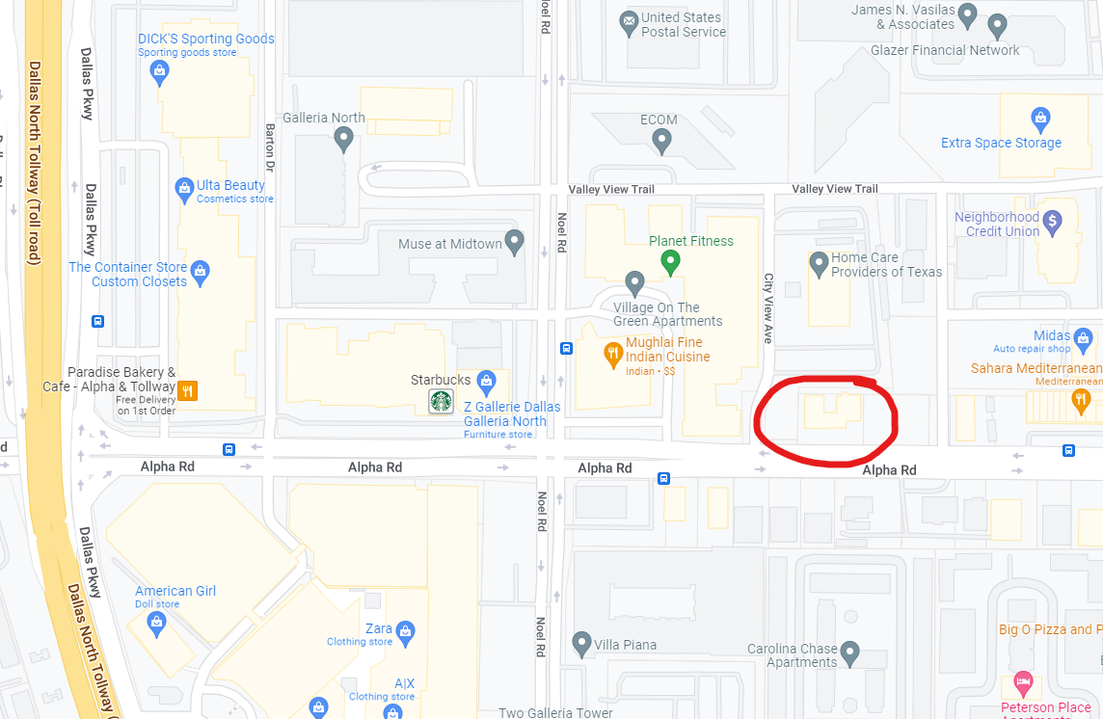
Taken from Google Maps

Key Personnel in the Crisis Communication Command Center
Position | Name | Phone | Address
Personnel | Thomas Petterson | 214-115-4698 | 5353 Alpha Rd Suite 210, Dallas, TX 75240
Management | Christopher Lane | 214-775-8947 | 5353 Alpha Rd Suite 210, Dallas, TX 75240
BC/DR Management | Brandon Tellez | 214-716-6516 | 5353 Alpha Rd Suite 210, Dallas, TX 75240
Crisis Management | Patrick Jones | 214-365-1651 | 5353 Alpha Rd Suite 210, Dallas, TX 75240
Human Resource | Sally Wheeler | 214-945-8012 | 5353 Alpha Rd Suite 210, Dallas, TX 75240

Phase 6 & 7

Backing up data
- What data will be backed up?
Client data, Sales and Purchasing records, Employee & Other personnel data/projects, IDS/IPS/Brute Force, along with any and all intrusion attempts.
- How will the data be backed up?
The data would be backed up via a combination of two data centers one off-site and one on-site consisting of Hadoop clusters (similar to the setup Google uses). Along with the two data centers hard copy backups will be kept in a climate-controlled safe room under 24 hr surveillance.
- What systems will be backed up?
All systems that are vital to the core functionality of the business such as the systems used to transfer the digital media that needs to be stamped onto disks that DigiKnight can sell.
- Software or technology used for the backup?
Google’s Hadoop Cluster Technology along with a combination of SSDs and SCSI Drives for the on-site hard copy storage.
- Will the backup be incremental, full, or both?
All Mission Critical systems would be backed up every 8 hrs. Timeshift backups every 2 hrs to minimize downtime and keep up continuity.
- How long will the backups take based on the method of replication?
While both data centers are fully capable of synchronizing with each other they also are able to function completely independent of each other thus allowing full system backups to be completed in less than 4 hrs.

Organizational Chart
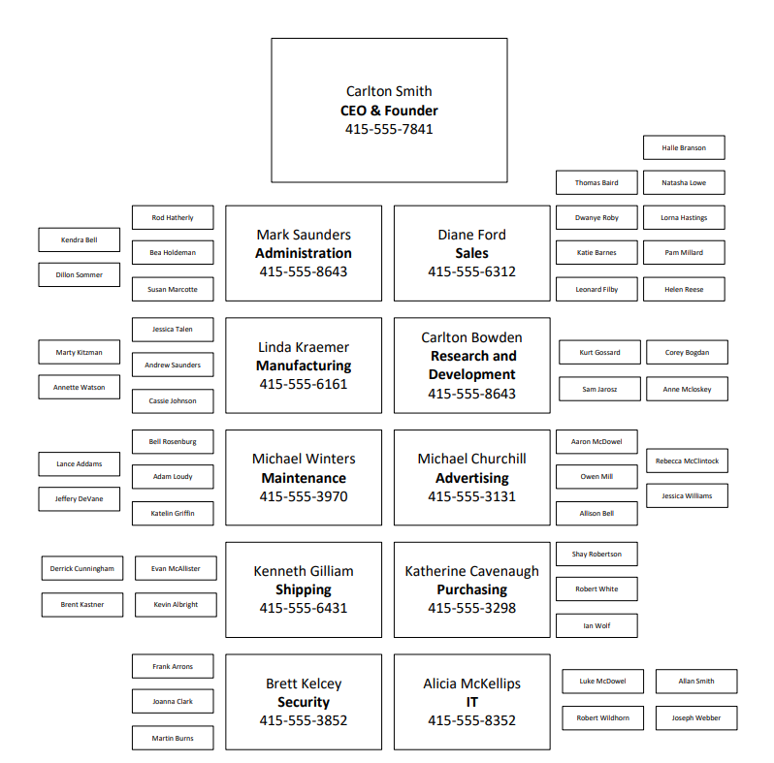

Phase 8

Location of emergency response organizations
- Fremont Fire Department
  - Address: 3300 Capitol Ave, Fremont, CA 94538
  - Phone: (510) 494-4200
  - Email: FremontFire@fremont.gov
  - Website: www.fremont.gov/96/Fire-Department
- Fremont Police Department
  - Address: 2000 Stevenson Blvd, Fremont, CA 94538
  - Phone: (510) 790-6800
  - Website: www.fremontpolice.gov/
- Hospitals
  - Fremont Hospital (Main)
    - Address: 39001 Sundale Dr, Fremont, CA 94538
    - Phone: (510) 796-1100
    - Website: www.fremonthospital.com
  - Kaiser Permanente Fremont Medical Center and Offices (Optional)
    - Address: 39400 Paseo Padre Pkwy, Fremont, CA 94538
    - Phone: (510) 248-3000
    - Website www.healthy.kaiserpermanente.org
  - Washington Hospital Healthcare System (Optional)
    - Address: 2000 Mowry Ave, Fremont, CA 94538
    - Phone: (510) 797-1111
    - Website: www.whhs.com
- Search and Rescue
  - Santa Clara County Search and Rescue
    - Address: 55 W Younger Ave, San Jose, CA 95110
    - Phone: (408) 450-3100
    - Email: info2@sccssar.org
    - Website:www.sccssar.org
- Hazardous Material Team
  - Fremont Recycling and Transfer Station
    - Address: 41149 Boyce Rd, Fremont, CA 94538
    - Website: www.fremont-recycling.com

BC/DR activation steps
The Activation Phase is in control of the initial actions taken to detect and assess damages caused by a disruption of the normal workflow. “Based on the assessment of the Event, sometimes according to the Incident Response Policy, the Contingency Plan may be activated by either the COO or Head of Engineering” (Dynamics, 2021). The Contingency Plan may also be activated by the Security Officer in the event of a cyber disaster.

Log Sequence
- First responder needs to notify the COO (Chief Operating Officer) of all information about the event
- The COO will contact the Response Teams and inform them of the event.
- The COO or delegated officer will then begin assessment procedures.
- The COO is to logically assess damage, gain insight into whether the infrastructure is salvageable, and begin to formulate a plan for recovery.
- If the plan is to be activated, the COO is to notify and inform team members of the details of the event and if relocation is required.
- Upon notification from the COO, group leaders and managers are to notify their respective teams. Team members are to be informed of all applicable information and prepared to respond and relocate if necessary.
- The COO is to notify the hosting facility partners that a contingency event has been declared and to ship the necessary materials to the alternate site.
- The COO is to notify remaining personnel and executive leadership on the general status of the incident.
- Notification can be messaged, emailed, or phoned in.

Determining structural damages, health, safety impacts, and risk template
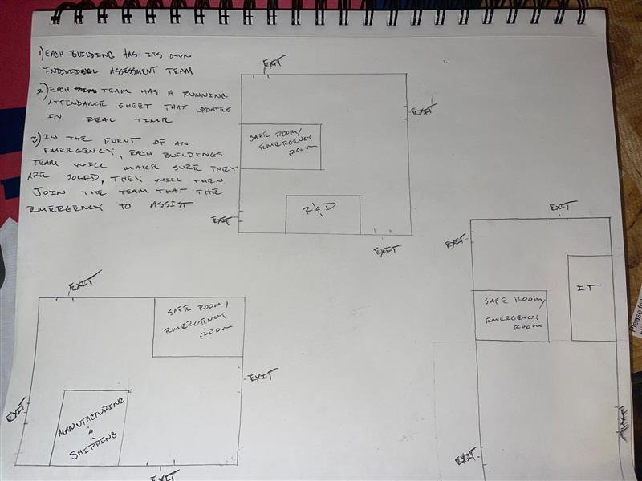

Location & testing of emergency systems
Every month we will test the functionality of our alarms and emergency signals. We will notify all employees so that they know it is merely a test and not an actual emergency. First aid kits, CPR equipment, and fire extinguishers will be kept with at least one in every room, and additional supplies in large rooms (around or over 10,000 sq ft.). Hazardous materials safety equipment will be stored at the safety points indicated on the map. 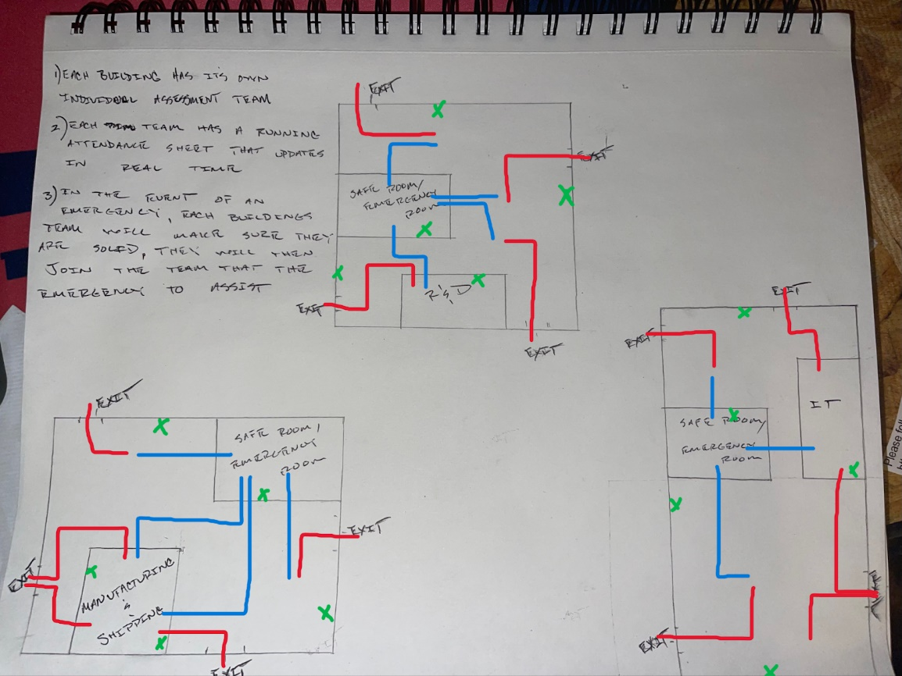
Immediate Egress Routes
Safety Point Routes
[X] Emergency Supplies: Defibrillator, CPR equipment, First aid kit, and fire extinguisher

Phase 9

Evacuation procedures
To ensure the safety of all personnel, all employees that have entered the building (whose presence will be recorded by their badges to get past the security doors) will convene at designated safety points based on their location within the facility. Each safety point lead (usually a manager or someone a manager has designated) will have a list of all employees that should report to their safety point. Each safety point lead will have a walkie talkie to communicate with other safety point leads and the emergency coordinator. They will take the attendance of all the people at their safety point and communicate with other leads when they have someone unexpected or are missing someone from their group. Each group will then receive instructions from the emergency coordinator and proceed on the egress route given to them. This will vary depending on the nature of the emergency. Water bottles will be stored at the safety points so all may have something to drink.

Policies & procedures in the event of accident or natural disaster
- The R&D, Shipping/Manufacturing, & IT departments will all have fire proof & blast resistant doors that will be secured by a passcode and retinal scan, as well as having the walls of the room be made of the same material.
- In the event of a fire an alarm will sound giving everyone in the area a 30 second lead time to evacuate, after the 30 seconds the doors will seal shut and a fire retardant foam will be deployed to prevent any damage to materials and or equipment.
- In the event of a flood or leak, a system will be put in place to cut off all water to the areas assigned critical status, upon activation waterproof containers will be automatically deployed to keep all materials and equipment in those areas safe and dry while the situation is assessed and handled
- In the event of a emergency if there are employees that are unable to evacuate in the alloted time there will be a safe room (made of the same materials that’s housing the equipment) in each of those buildings where the departments are located that will be on a completely separate power grid along with plumbing and air with enough provisions to last two weeks to keep the employees satiated and safe while rescue attempts are being carried out.
- Each of the buildings will have a minimum of 4 additional exit doors not including the main doors in and out of the buildings. In the event of an emergency there will be lights that will be on a completely separate circuit that will light up both the floor and the walls at eye level to illuminate the way to the exits and to safety. Drills will be run at random a minimum of 4 times a month to make sure everyone knows exactly what to do and is prepared in the event something actually does transpire.

Checklist for contracting a disaster recovery specialist
 | Items for contacting and interviewing a disaster recovery specialists | Status (Completed, Pending, or N/A)
 | Disaster recovery specialist contact information and location
 | Names of employees who contacted the disaster recovery specialist
 | How disaster recovery specialist can be needed and utilized
 | What are the specific contracts with the disaster recovery specialists
 | What are ways to fund the disaster recovery specialists

Checklist for contracting a supplier
Evaluate Supplier Risks
- Check business product and service track-record
- Check creditworthiness (financial health)
- Formulate contingency plans
Discuss & Agrees
- Expected nature, volume, and frequency of requirements
- Product or service specifications
- Lead times
- Any extras required (e.g. barcodes, labels)
- Order placement requirements and format
- Pricing and discounts
- Payment terms
- Delivery process / logistics
- Returns and accounts credits
- Suppliers training requirements or orientations sessions (if required
Share All Information Internally
- Accounts department
- Purchasing department
- Warehousing and inventory control
Share Information with the Supplier
- Record all agreed terms and send for formal approval
- Provide invoicing details
- Give contact details for purchasing manager, accounts, and warehousing / logistics
- Provide training and orientation sessions as needed

Create a checklist for contacting and working with customers
- Set clear service expectations.
- Speak from the company’s voice.
- Listen more than you talk.
- Provide more than the customer needs.
- Respond as quickly as possible.
- Put the customer first.
- Learn everything about your company’s products and services.
- Match customer needs with product solutions.
- Create and follow the chain of command.
- Help your fellow teammates.
- Remain calm during crises.
- Alleviate any point of confusion.
- Build guidelines to swiftly and fairly resolve issues.
- Don’t take it personally.
- Stay professional and polite.

Phase 10

Assessment for determining inventory or list of critical resources at damaged site
- How many buildings are without power or other resources? Check electrical lines, gas lines, potable water (drinking water) and other, etc. Then after doing so, immediately notify the proper authorities.
- Which buildings safe rooms have been activated? Immediately reach out to FEMA, Police, Fire and Rescue. While they are en route immediately assess all damage to structure and otherwise along with setting up a staging point to care for any injured
- Which of the critical departments Emergency/Disaster systems have been activated? Immediately determine which of the Critical Departments Emergency/Disaster systems have been activated. Once that’s been done secure the facilities and wait for appropriate authorities along with the specialized teams to assess the extent of the damage along with recovering data/equipment.
- Are all employees currently present and accounted for? Immediately assess the running attendance list that is updated every minute on the minute. Have each team from each department take an immediate count of who’s there after the count then get together to compare to see who’s missing. After doing so, immediately notify senior management and the proper authorities.

Policies & procedures for employees to follow explaining proper safety guidelines
Each building will have its own disaster and recovery team with two different squads that will rotate every 12 hrs. Each building will have automated alarms to law enforcement, fire and rescue, external hazmat teams, etc. Then all systems including personnel, IT, RD, Shipping/Manufacturing will be set to automatically send the last 3 hrs to the cloud and to the back up facility so that during recovery we can see everything that was going on across all systems in order to determine a cause. On top of that each time will run through a minimum of 3 different scenarios every week to make sure that everyone on every shift will be fully prepared in the event of an emergency. In the event of an emergency each team will tend to their building first, then as they finish they will go assist with whichever team is still trying to go through their checklist.

Assessment for determining inventory or building, utilities (gas, electric, water)
Inventory or building utilities | Time | Location | What causes the incident? How to prevent further damages? | Potential restoration | Impact of Operations | Potential Financial Loss
Suppliers |  |  |  |  | Low  Medium  High | Negligible  Significant  Serve
Water |  |  |  |  | Low  Medium  High | Negligible  Significant  Serve
Gas |  |  |  |  | Low  Medium  High | Negligible  Significant  Serve
Electric |  |  |  |  | Low  Medium  High | Negligible  Significant  Serve

Inspect for hazardous materials, chemicals, or hazardous conditions
Type of Hazard | Time | Location | What causes the incident? How to prevent further damages? | Potential restoration | Impact of Operations | Potential Financial Loss
Explosive |  |  |  |  | Low  Medium  High | Negligible  Significant  Serve
Gasses |  |  |  |  | Low  Medium  High | Negligible  Significant  Serve
Flammable Liquids |  |  |  |  | Low  Medium  High | Negligible  Significant  Serve
Flammable Solids |  |  |  |  | Low  Medium  High | Negligible  Significant  Serve
Oxidizers |  |  |  |  | Low  Medium  High | Negligible  Significant  Serve
Poison |  |  |  |  | Low  Medium  High | Negligible  Significant  Serve
Radioactive |  |  |  |  | Low  Medium  High | Negligible  Significant  Serve
Corrosive |  |  |  |  | Low  Medium  High | Negligible  Significant  Serve
Misc. |  |  |  |  | Low  Medium  High | Negligible  Significant  Serve

Inspect resources and vital records for damage
Type of Damages | Time | Location | What causes the incident? How to prevent further damages? | Potential restoration | Impact of Operations | Potential Financial Loss
Water |  |  |  |  | Low  Medium  High | Negligible  Significant  Serve
Fire |  |  |  |  | Low  Medium  High | Negligible  Significant  Serve
Dust |  |  |  |  | Low  Medium  High | Negligible  Significant  Serve
Ice |  |  |  |  | Low  Medium  High | Negligible  Significant  Serve
Wind |  |  |  |  | Low  Medium  High | Negligible  Significant  Serve
Physical  (natural and man-made threats) |  |  |  |  | Low  Medium  High | Negligible  Significant  Serve

Nature-based test scenario
In the case of any nature-based scenario involving a threat to the company such as earthquake, mudslide, wildfire, tornado, flash flood, hurricane, etc. The evaluation team will need to move into action as soon as possible. The team will gather information, determine the best plan of action, and enact those plans within a reasonable time frame. If people or equipment need to be moved to off site areas they will need to follow the instructions of the plan provided in the above sections. Because you are unsure of the amount of damage and the risk of additional damage resulting from aftershocks, the Command Post should not be located inside the building.

Man-made-based test scenario
In the case of any man-made-based scenarios such as bomb threats, riots, power outages, chemical spills, evacuations, computer/data/network outages, biological threats, employee strikes, ect. The evaluation team will need to act fast and follow the plans provided to the best of their abilities. Communication is essential to your ability to operate your business, and whilst comms may fail during natural disaster or power outage, communication is so important it deserves its own place within your BCP testing procedure. Preparing non-traditional methods of staying in contact with your team such as emergency notification software will allow you to keep in touch no matter what happens. Testing your BCP for the eventuality of a data breach will ensure your business has a proactive response to a loss, whether that’s caused by an external attack or internal error.

In the events of a mudslide
Each department and their leads will partake in a tabletop exercise at different times. A die will be used to create some randomization within the test so that it is not the same every time. The managers will lead the test and ask questions to the participants to determine if they know how to correctly respond to the scenario. Suggestions for improvement will be taken from any employees participating. Any assembly locations or emergency equipment that would be needed during that theoretical exercise will be visited by the team and they will go through how to operate that piece of equipment (such as a generator) or what to expect at an assembly location. A list of possible scenarios, as well as maps and any supplies that would be needed in an actual emergency will be needed for demonstration and learning purposes.

Memo to the CEO of the company explaining how testing of the plan is going to be performed
Dear CEO, in order to test the effectiveness of our emergency plan as well as educating our employees on how to carry out this plan, we will need to conduct tests of our plan. There are different kinds of tests from merely theoretical tests where employees simply answer questions as to what they should do in an emergency scenario, to full blown mock-testing where the entire facility can be put into a disaster scenario and we can make sure all employees know exactly what they should be doing as well as testing our emergency equipment such as generators to make sure they actually work. Theoretical testing will be very quick, but many employees will likely not remember what they need to do in a disaster scenario, whereas mock testing will take some time to orchestrate, execute, and review, but it will also make certain that all employees know what to do in the event of an emergency, thus lowering possible danger and damage to equipment.
We recommend a middle-ground approach that we can perform with some frequency (around once a month). Each department and their managers should be involved. One department or team at a time can go through a tabletop exercise detailing what they would do in a situation, then they will go and perform those specific tasks around the facility. This lowers the time needed to prepare and execute the plan, and doesn’t require the entire facility to stop operations. These will take roughly one hour to complete. It is still recommended that we perform a full mock test at least once every two quarters to ensure all the different moving parts work together as we have envisioned. These mock tests will take roughly 3 hours to complete. During this time the facility will not be able to operate, so loss of profit will be around $400,000 per hour. Our web servers will continue to operate so that any partners that need access to our online services will not be affected by our tests.
To determine the effectiveness of our tests the following post mortem analysis will be conducted. Each lead will answer the following questions:
- Did I know how to lead my group according to the emergency procedures?
- How well did my group understand how to carry out their individual tasks?
- Were all necessary emergency tasks completed?
- Did all equipment operate as intended?
- Was the group able to quickly navigate to the safety point and the egress point?
- Was the safety point easily accessible and was it ready to receive my group?
- Was there any confusion?
- Were any suggestions for improvement offered or do I have suggestions?

Phase 11

Planned maintenance
Planned maintenance is defined as “a proactive approach to maintenance that focuses on minimizing the downtime and costs associated with breakdowns” (Jeans, 2021). Due to the minor or major changes with technology, the Business Continuity Disaster Recovery plan needs to constantly change over a period of time. Additionally, assigning task priority on day-to-day operations to reduce the maintenance costs and improve time management.

Advantages & disadvantages of retaining members
There are a couple of advantages and disadvantages of retaining members of the original planning team. It is listed below:
Advantages/Pros
- Having experienced members to follow the regulations and rules
- Reducing the cost of the organization
- Creating a quality workplace
Disadvantages/Cons
- Creating an inefficient and destructible work environment
- Members not performing the best of their ability
- Not improving the quality of the BCDR plan

Recommendation of the BCDR plan up to date
The Disaster Recovery aspect of this BCDR plan shouldn't ever change much, but it is a good idea to periodically evaluate your backup processes for kinks and see if you need to make any improvements. When it comes to the Business Continuity aspect of this plan, periodic updates are key. Staff change departments, leave for other companies, or are promoted. When personnel shifts happen, BCDR plans should be updated so that the most current roster of executives and employees is available.

Approaches & reviewing the plan
There are many approaches to use when it comes to reviewing plans and making recommendations for the company, but, I would recommend the Bottom Up Approach. This approach is about involving the employees at the bottom of the company, to hear their thoughts as well as the employees near the top. This would help involve the company as a whole and make employees at the lower levels feel like they have a say in what happens with the company. To encourage employees to come to these meetings the company can offer free coffee and donuts to any employee that shows up.

Different way plan updates can be distributed
All team leads will have Ipads and laptops that they will carry with them throughout the day and these will be connected directly to the main server that will run the automated checks at the scheduled times with up to the minute inventories of personnel, material and equipment alongside with the disaster scenarios.
Checklist form for managing updates to intranet documents
All forms will be electronic and will be backed up every day (both during the day and at night) at predetermined times. Also along with the team leads having the ipads and laptops with everything at their fingertips the supervisors, department heads and senior management will have access to the same information so in case of emergency, inspection, etc all relevant and important information will be accessible at a moments notice.

Formalizing the BCDR plan change management processes
Change management has always been an issue in all walks of life. Software developers have been the ones to perfect the process of change management with Version Control Systems (VCS). It might seem overkill to house our BCDR plan on a VCS such as GitHub, but there are many benefits for doing so. Version control systems offer many features such as read/write permissions and commit messages. These will tell us who authored exactly what changes at what time, and it will provide the author’s reasoning for that change. These changes cannot be done at random by anyone, but must go through an approval and testing process. GitHub has features that can require changes to be approved by a certain number of authorized users before being merged into the document. There are also a number of integrations offered by GitHub and third parties that can automatically notify configured users of changes to documents. This will also allow our BCDR plan to be hosted online, thus allowing anyone we wish to be able to view the plan.
Changes can be suggested (via a pull request) by any manager at DigiKnight. This is done so that those who work in the day to day affairs of DigiKnight can see how parts of the plan may falter and suggest improvements. These changes will be reviewed by our BCDR specialists, they will then implement testing of the suggested changes and engage in a dialogue with the author of the proposed edits. After both parties are satisfied with any additional changes to be made or perhaps none at all, the changes will be implemented in the main plan. This will trigger the third party services to notify our stakeholders as well as all relevant executives and other parties.

References
America’s critical infrastructure: Threats, vulnerabilities and solutions. (2018, October 2). Security Info Watch. https://www.securityinfowatch.com/access-identity/access-control/article/12427447/americas-critical-infrastructure-threats-vulnerabilities-and-solutions
Apelectric. (n.d.). Generac 7209 24kW guardian generator with Wi-Fi. AP Electric & Generators LLC. Retrieved February 12, 2022, from https://apelectric.com/generac-7209-24kw-guardian-generator/?gclid=Cj0KCQiA0p2QBhDvARIsAACSOOMZ8x69THJFAvzHLFOTKNY1YsV0bHiduEPNXCvl48oY-7OYkGJv_9MaAk0rEALw_wcB
Crocetti, P. (2018, December 30). What is warm site? - Definition from WhatIs.com. SearchDisasterRecovery. https://www.techtarget.com/searchdisasterrecovery/definition/warm-site
Crisis Command Centre 2.0. (n.d.). https://www2.deloitte.com/content/dam/Deloitte/in/Documents/risk/in-ra-CrisisCommandCentre-noexp.pdf
DigiKnight Technologies: Company Info. (n.d.). https://synchronic.uat.edu/courses/4693/pages/digiknight-technologies-company-info?module_item_id=441279
Dynamics, R. (2021, January). Business Continuity and Disaster Recovery. 18. Business
Continuity and Disaster Recovery - Rent Dynamics Security PSP. Retrieved March 31, 2022, from https://security.rentdynamics.com/bcdr/#notification-and-activation-phase
Inventory list. (2021, August 19). Create more with Microsoft templates. https://templates.office.com/en-us/inventory-list-tm16390566
Jeans, N. (2021, November 15). What is planned maintenance? | Definition, types & examples. Hippo CMMS | Maintenance Management Software Solution | Get Free Trial. https://hippocmms.iofficecorp.com/blog/planned-maintenance
Loopnet. (n.d.). Oakland, CA industrial space for lease | LoopNet.com. LoopNet: #1 in Commercial Real Estate for Sale & Lease. Retrieved February 12, 2022, from https://www.loopnet.com/search/industrial-space/oakland-ca/for-lease/?sk=cd65bfe4e376cf180cf9940247f01441
Reed, J. (2020, November 27). Comparison of Disaster Recovery Sites: Which One to choose?
Official NAKIVO Blog. Retrieved February 28, 2022, from https://www.nakivo.com/blog/overview-disaster-recovery-sites/#:~:text=A%20warm%20site%20is%20considered%20the%20middle%20ground,they%20are%20not%20equipped%20in%20the%20same%20way.
Support, T. (2021). The Pros and cons of cloud backup. Managed IT Services, Copiers,
Telephony. Retrieved March 5, 2022, from https://www.appliedi.net/blog/the-pros-and-cons-of-cloud-backup-and-disaster-recovery/

QE Buildings. (n.d.). New metal buildings – QE building Co. QE Building Co. – Metal Buildings | Built to Last. Retrieved February 12, 2022, from https://qebuildings.com/new-metal-buildings/?gclid=Cj0KCQiA0p2QBhDvARIsAACSOONmaqsDN0IOB12qzkCh7gaqm0esluBDzlsCFKRXrsqPXhWRiXxfBTgaAotgEALw_wcB#/item/80x100x16-metal-building
Security, H. (2022, February 9). Risk management. FEMA.gov. Retrieved February 19, 2022, from https://www.fema.gov/emergency-managers/risk-management
What to do when a BC/DR plan goes awry. (n.d.). SearchDisasterRecovery. https://www.techtarget.com/searchdisasterrecovery/tip/What-to-do-when-a-BC-DR-plan-goes-awry

